Procedurally Generated 3D Worlds for Video Games

**Ivaylo Hinov**

**April 2018**

**Dissertation submitted in partial fulfilment for the degree of**

**Bachelor of Science with Honours in Software Engineering**

**Division of Computing Science and Mathematics**

**University of Stirling**

Abstract

The purpose of this project was to explore and design a suitable solution for procedurally generating a 3D game world. There are various ideas on the Internet discussing how to go about achieving that. However, there are little code examples that provide a solution that tackles most of the problems that come up. Some issues such as defining the objects that will be used to generate the level, the collision between those objects, so they do not overlap do not have many good code examples. These are some of the issues that a well-implemented solution should have solved. Moreover, those code examples do not provide a good user interface for those who would like to use the code to build their own games’ world using procedurally generated levels.

The objectives set for the project were to implement a solution to the described problem that provides users not only with an example of well-commented, easy to read and understandable code that they can use and expand but also let them focus on designing and adding features to their game world, rather than focusing on building the level itself. Game engines provide developers with the tools with which to create fantastic games. The project would go one step further by using a game engine to implement a solution to the problem and let developers expand and build their games using the solution. However, for this to be viable, the game worlds that the solution generates needed to make sense to the player. Hence an essential objective of the project was that the generated levels were logically connected - the way they were joined made sense for the player exploring them.

The Unity3D game engine was used for implementing the solution to the problem. The engine was chosen over others as it is easy to learn and provides a friendlier interface to new users. The solution is written in the C# programming language. After the research phase, the initial idea for a solution for tackling the problem was changed. The new solution would focus on working with imported room models. Models that are premade in a 3D computer graphics program, giving the user the freedom to design and model the rooms however they see fit. This approach was taken instead of generating the rooms themselves because many features can be added to a model in a 3D computer graphics program which the implemented algorithm cannot know in advance.

The project successfully creates a procedurally generated 3D dungeon level. It builds an entire level using the room models that have been provided and set up by the user. It also includes multiple options for several of the implemented features such as player collision setup. Furthermore, the solution can easily be expanded to include even more features – such as filling the rooms with other objects, monsters that the players can fight or hidden treasures.

Attestation

I understand the nature of plagiarism, and I am aware of the University’s policy on this.

I certify that this dissertation reports original work by me during my University project except for the following (*adjust according to the circumstances*):

* The code in chapter 3.3.6, Figure 11, was written by Marcin Seredynski. [7]

**Signature:** *Ivaylo Hinov* **Date: 17/01/2018**

Acknowledgements

I would like to thank Professor David Cairns for his advice and support during all stages of this project.

I would like to thank my friend Todor Hlebarov, who not only created the room models but who has also supported me throughout this project and many others.

I would like to acknowledge Mr Seredynski, who inspired the solution that was implemented for this project.

Table of Contents

Abstract ii

Attestation iii

Acknowledgements iv

Table of Contents v

List of Figures vii

1 Introduction 1

1.1 Background and Context 1

1.2 Scope and Objectives 1

1.3 Achievements 1

1.4 Overview of Dissertation 2

2 State-of-The-Art 3

2.1 Procedural Content Generation Techniques 3

2.1.1 Perlin Noise 3

2.1.2 Simplex Noise 4

2.1.3 Midpoint Displacement 5

2.1.4 Diamond-Square Algorithm 6

2.1.5 Heightmaps 7

2.2 Procedural Content Generation Application In Games 7

2.2.1 Procedural Content Generation in “Sir, You are Being Hunted” 7

2.2.2 Room-based Procedural Generation in Diablo 3 10

2.2.3 The Procedural Generation Technique Behind the Game Path of Exile 11

2.2.4 Procedurally Generating Levels in the Video Game Warframe 14

2.2.5 Generation of Worlds Made of Blocks in Minecraft 15

2.2.6 Generation of unique items in Borderlands 17

2.2.7 Generation of planets in “Outtera” and “No Man’s Sky” 18

2.3 State of the Art Summary 21

3 The Procedural Level Generation System 22

3.1 Engine and Programming Language 22

3.2 The Idea Behind the Implemented System 22

3.3 System Implementation 23

3.3.1 System design 23

3.3.2 Algorithm Overview 24

3.3.3 The Level Generation Algorithm In-depth 24

3.3.4 Tracking Room Collisions 27

3.3.5 Room Prefabs 29

3.3.6 Room Connection Rules 31

3.3.7 Room Connections 32

3.3.8 Fragments 33

3.3.9 Making exploration worthwhile – ‘Closing off Paths’ 35

3.3.10 Tags and Layers 36

3.3.11 Player Collision 37

3.3.12 Extending the Generator Example – Spawning Dungeon Objects 38

3.3.13 Debugging 39

3.4 Testing the Generated Levels 40

4 Conclusion 43

4.1 Summary 43

4.2 Evaluation 44

4.3 Future Work 45

References 48

Appendix 1 – User Guide 51

List of Figures

Figure 1. Perlin noise sample(left) [23] vs Random noise (right)[28] 3

Figure 2. Procedural Fire Texture [27] 4

Figure 3. Example of simplex noise. [31] 5

Figure 4. The algorithm in practice – the initial square is the top left. The first two steps – calculating the midpoint and midpoints are displayed in the first row. [32] 6

Figure 5. Midpoint Displacement algorithm example. [32] 6

Figure 6. The side-midpoint (circled) is computed by averaging the four corners of the surrounding diamond (in the dark-red rectangles) [33] 7

Figure 7. Strict grid(left) and Disturbed grid(right) Voronoi cells layouts [14] 8

Figure 8. Scene view of a small village layout. [14] 9

Figure 9. Example of a generated level in “Sir, you are being hunted” [15] 9

Figure 10. Screenshot of the presentation by the game's developers [34] 12

Figure 11. Fractal Coastline [35] 12

Figure 12. Screenshot of the systems outdoor level generator. [34] 13

Figure 13. Some of the styles/themes for each of the room sets in Warframe. [36] 14

Figure 14. Example of a generated level using ‘Orokin Tower’ room set. 15

Figure 15. Plain/Grass biome [11] 16

Figure 16. Sand biome [10] 16

Figure 17. Snow biome [8] 17

Figure 18. Jungle Biome [9] 17

Figure 19. The lists the system chooses from when an enemy is killed. [4] 17

Figure 20. Same weapon but completely different properties. 18

Figure 21. A close look at a forest generated by the Outtera Engine [12] 19

Figure 22. The generated planet Earth [12] 19

Figure 23. Screenshots of planets in No Man’s Sky [13]. 20

Figure 24. Example of a room model that is textured and imported into Unity3D. 23

Figure 25. Part of a level generated by the system. 24

Figure 26. Screenshot of the serialized variables that the user can modify from within the Inspector 25

Figure 27. Comment that is displayed when users put their mouse cursor on the ‘Rooms’ text. 27

Figure 28. Part of the Script Lifecycle Flowchart in Unity3D [18] 28

Figure 29. Example of how the Physics class is used to detect room collisions. 28

Figure 30. Setting up the collider for the room prefabs. 29

Figure 31. The exposed variables from the Room Script. 30

Figure 32. Screenshot of a room GameObject on the left and its prefab on the right. 30

Figure 33. Defining the room types in an enum class 31

Figure 34. ‘ConnectionRules’ script exposed variables. 31

Figure 35. System using default connection rules if none have been set. 32

Figure 36. Showing the ‘gizmos’ which are the small spheres indicating the exits position. 32

Figure 37. Calculations for correctly rotating and attaching one room to another. 33

Figure 38. Exposed variables to adjust the fragments. 34

Figure 39. Example of a door fragment. 34

Figure 40. The ‘Has Priority’ variable that determines whether a fragment is always spawned on top of this exit instead of randomly between this and the connected. 35

Figure 41. Screenshot of two connected rooms – ‘Hall’ type and ‘Junction’ type. 35

Figure 42. Settings for closing off paths. 36

Figure 43. Tags and layers list. 36

Figure 44. Parameters of the Physics.OverlapBox function. 37

Figure 45. Player to Room collision settings, showing both options available. 37

Figure 46. Components of a room prefab including the colliders that will be used for player collision. 38

Figure 47. Dungeon Object Placement class user interface 38

Figure 48. Example of debugging log. 39

Figure 49. An indication of how many game objects have been created during the level generation. This is found in the Hierarchy. 40

Figure 50. Survey results for the first question. 41

Figure 51. Survey results for the second question. 41

Figure 52. Survey results for the third question. 42

Figure 53. Survey results for the fourth question. 42

Figure 54. A basic design of a model that can be used with the system – showing a path between two sides of the tile and trees around that path. 46

# Introduction

## Background and Context

The project explores various ways of procedurally generating content – algorithmically creating random game elements in the level or the level itself. On the one hand, procedural content generation gives advantages such as faster level creation, reduces the size of the game files, and lets players experience a different level layout every time they play it. On the other hand, there are disadvantages to it as well. Using procedural content generation, one can easily create repetitive content or implement static features which would be more time consuming as the generation scripts would have to be modified. This method of creating game levels has been in use since 1980 when it was used to develop the game “Rogue”, which led to a whole new genre of games called “roguelikes”. “Roguelikes” are a subgenre of Role-playing games, more specifically, dungeon crawlers. In dungeon crawlers, players navigate through procedurally generated levels while battling enemies. The game “Binding of Isaac” which was released in 2011 is part of that genre and uses procedural generation. However, generating levels is not the only use for this method. Video games like “Spore” and “Borderlands” incorporate procedural generation differently. “Spore” uses this method to generate new animations for each of the creatures in the game, while “Borderlands” uses it to create new item properties.

## [Scope](http://www.cs.stir.ac.uk/~kjt/research/conformed.html) and Objectives

The projects aim is to design and implement a system that uses procedural content generation to create game levels by using the game engine Unity3D as a foundation for the algorithm. The system will produce levels with a different structure layout every time a new level is generated. It will also be able to reproduce the same level when needed.

Furthermore, the levels themselves need to make sense to the player exploring them – there must not be any overlapping elements, and the player should not get lost for too long. The system will generate the levels using room models that are imported and set up by the users. However, it will also allow for a wide range of customisations to be made to the models in the Unity3D editor. These features, in turn, will give the users the freedom to create a complete dungeon game with treasures and monsters, without having to worry about the level creation.

## Achievements

The system that was designed and implemented has met most of the objectives of the project. It procedurally generates game levels using room models. It provides a friendly user interface through which a person who wishes to expand the system into a game, can do so. Moreover, it comes with tooltip comments to help explain the features to the user and well-commented script functions if they would wish to modify the code components. However, there are several disadvantages due to the way the system was implemented which are discussed later in the dissertation.

## Overview of Dissertation

The dissertation follows the process behind the development and release of a software product that aims to achieve a convincing, thought-provoking and fun experience through a procedural content generation system. Such a system is widely applied in computer and console games. Its target application is in the gaming industry. The complete process, as far as my research has conducted, involves six steps, that go as described:

1. Algorithm and techniques research – involves analysing algorithms and other pieces of work that involve procedural content generation and discussing their strengths and weaknesses.
2. System design – the structure of the system and its components are defined.
3. Implementation – the code for the solution is written.
4. Testing/Debugging – generated levels were tested to ensure the system is working as intended and if a problem is found, steps 2 and 3 are repeated.
5. Polishing - comments are added and updated. Function and variable names are modified if necessary in order to give an indication as to what they do. Any unused scripts are removed.
6. Release – the product is ready to be used by others. Project source files are made available to the public.

# State-of-The-Art

The term procedural content generation describes using mathematical formulas and algorithms to generate content. It is a versatile approach, which can be used to create exciting and unique content - from creating whole worlds or levels, all the way down to objects and their properties. Not only can this approach be applied to coding problems, but it can also be used in other fields such as Art to create natural shapes and objects. Despite procedural generation being known for decades, it has only recently begun to scratch the surface of its application in video games. A lot of the games that use this approach have implemented it in various ways, depending on the purpose it serves. Each of those games uses a combination of various algorithms and techniques for procedural content generation such as Perlin noise.

## Procedural Content Generation Techniques

This chapter goes over some of the more popular and used algorithms when it comes to procedural content generation – Perlin and Simplex noise, Midpoint displacement, Diamond-Square and Heightmaps.

### Perlin Noise

The Perlin noise algorithm was created by Ken Perlin in 1983, and it was used to generate procedural textures. However, it can be used to create other various effects such as clouds, fire and landscapes. The effects it generates have an organic appearance. The organic appearance is achieved by using pseudo-random values that gradually increase and decrease rather than using completely random values at each point.

** 

1. Perlin noise sample(left) [23] vs Random noise (right)[28]

The Perlin noise sample shows how the random values are not really random and there is a gradual transition between the values. This results in a much more organic texture as can be seen from both the sample above and below.

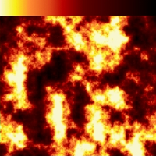

1. Procedural Fire Texture [27]

Perlin noise is one of the best procedural algorithms as it produces natural shapes. It does not require any computer memory usage and generates highly detailed shapes. However, there is now a better algorithm that is an improvement of this one and was designed by the same person.

### Simplex Noise

Simplex noise was created by Ken Perlin in 2001. It addresses the limitations of his previous noise algorithm. While ‘Perlin noise’ works great in 2 or 3 dimensions, it does not scale in higher dimensions. Hence why ‘Simplex noise’ was created. It improves the classic noise function by reducing the computational complexity of the algorithm and also reduces the computational cost in higher dimensions, such as 4D and even 15D.[26] These improvements are achieved by partitioning the space into regular chunks using simplex objects rather than basing the functions on a square grid which remove the need of using linear interpolation to calculate each of the values on the grid.. [24] A simplex is “a basic geometric element in a Euclidean space, being a line segment in one dimension, a triangle in two dimensions, a tetrahedron in three dimensions, and so on: used in topology and linear programming” [30].



1. Example of simplex noise. [31]

Simplex noise provides the same advantages as Perlin noise and is even more efficient than Perlin noise in higher dimensions. The only drawback of it would be the heavy math behind it as it can be difficult to understand.

### Midpoint Displacement

The idea behind the Midpoint Displacement algorithm is quite simple. It uses a square array with random values assigned to each of the four corners. The middle point value is then set to the average of the four corner values plus an additional random value. After that step is done, the value of the midpoint on each side of the square is set to the average of the two corner values the point is in between. This process is repeated for each of the new squares that are formed.

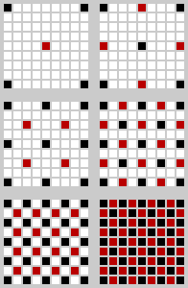

1. The algorithm in practice – the initial square is the top left. The first two steps – calculating the midpoint and midpoints are displayed in the first row. [32]

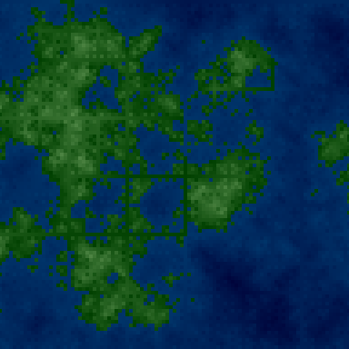

1. Midpoint Displacement algorithm example. [32]

The speed with which the algorithm calculates the values in the array is quite exceptional. However, the data structure must be stored in memory “because pixels reference other pixels” and must have a width and height of 2n+1.[32]

### Diamond-Square Algorithm

The Diamond-square algorithm is similar to the Midpoint-displacement algorithm. It uses a square data structure with random values for each of the four corners. It then sets the value of the middle point of the square to the average of the four corners plus a random value, just like Midpoint-displacement. The two algorithms differ in the next step – calculating the midpoint value. Instead of using the values of the two corners that the midpoint is in between, the Diamond-Square algorithm uses the four points around the midpoint that form a diamond.

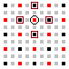

1. The side-midpoint (circled) is computed by averaging the four corners of the surrounding diamond (in the dark-red rectangles) [33]

Not only does this algorithm have the same speed efficiency as the Midpoint-displacement algorithm, but it also produces better results. However, it suffers from the same drawbacks – the data structure must be stored in memory.

### Heightmaps

“Heightmap is a [raster image](https://en.wikipedia.org/wiki/Raster_graphics) used to store values, such as surface [elevation](https://en.wikipedia.org/wiki/Elevation) data, for display in [3D computer graphics](https://en.wikipedia.org/wiki/3D_computer_graphics)” [28] It stores the distance of displacement with the colour white being the maximum height and black being the minimum height. The available heights, however, can be further increased by using other colours. The heightmap can be used to quickly generate complex terrain and landscapes based on the values that are stored in it. Hence one of the noise algorithms can be used to generate the values within the heightmap and produce terrains such as mountain ranges or cave systems.

## Procedural Content Generation Application In Games

This section focuses on the application of procedural content generation in some of the more popular video games. The games that will be discussed are ‘Sir, you are being Hunted’, ‘Diablo 3’, ‘Path of Exile’, ‘Warframe’, ‘Minecraft’, ‘Borderlands’, ‘No Man’s Sky’ and ‘Outtera’.

### Procedural Content Generation in “Sir, You are Being Hunted”

The video game “Sir, You are Being Hunted” is a horror game in which the player is hunted by procedurally generated AI robots in a procedurally generated “British countryside” world. For the development of the game, the Unity3D engine was used. The world and AI generated by the game’s system provide the players with a different challenge every time they play it – all the way from getting to know the lay of the land anew, down to the smallest detail including positioning of the enemies. The world in which the players find themselves is formed of 5 islands. Each of these islands is procedurally generated using, what the developers have named their generation system, “British Countryside Generator”. The system uses Voronoi diagrams to generate the layout of the island. “They work by taking a number of points in space and then identifying the boundary lines that lie between those points.” [14]

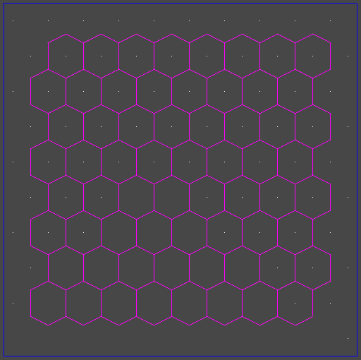 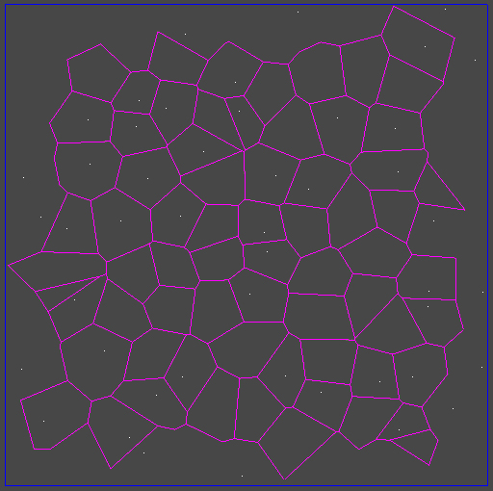

1. Strict grid(left) and Disturbed grid(right) Voronoi cells layouts [14]

It is called “disturbed grid distribution” by the developers as it uses uniformly distributed points on a grid instead of using randomly selected points. Moreover, this allows for small movement between each of the grid locations thus resulting in the organic division of the cells. This movement can be seen in the figure above on the right side. The diagram is then used to create a heightmap which is combined with several Perlin noise algorithms to smooth out slopes and create more organical forms.The system uses all of that data to generate a terrain splatmap. The splatmap essentially defines how different textures get combined. Noise functions also are used to ensure the textures have a more organic look when they are combining – so they do not just go from sand to grass in a single pixel. After these zones are textured, the system proceeds with adding models to those zones. However, each zone is responsible for what content is placed inside of it, though data is still being shared between them.

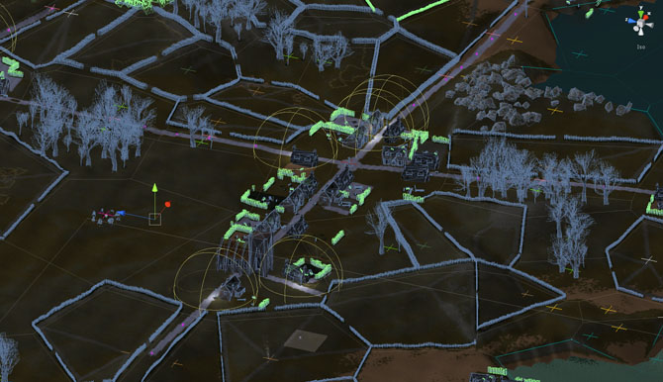

1. Scene view of a small village layout. [14]

When it comes to the generation of the village cells, they use more complex scripts. There are factors like roads, house gardens and smaller components such as garden objects that need to be considered. The roads are generated outwards from the village centre, and after that, they are aligned with the buildings. Next, the house gardens are populated with various elements and features. This contributes to the realism of the game, and it ensures the players feel like they are exploring an actual village while being hunted by enemies. Furthermore, not only are the enemies procedurally generated but also the animals that are present in the game. For example, the birds on the trees fly away if they are disturbed which in turn can be used as a warning to the player to stay away or to alert the robots to the player's position. All of these small details contribute to making this procedurally generated world creative and interesting.

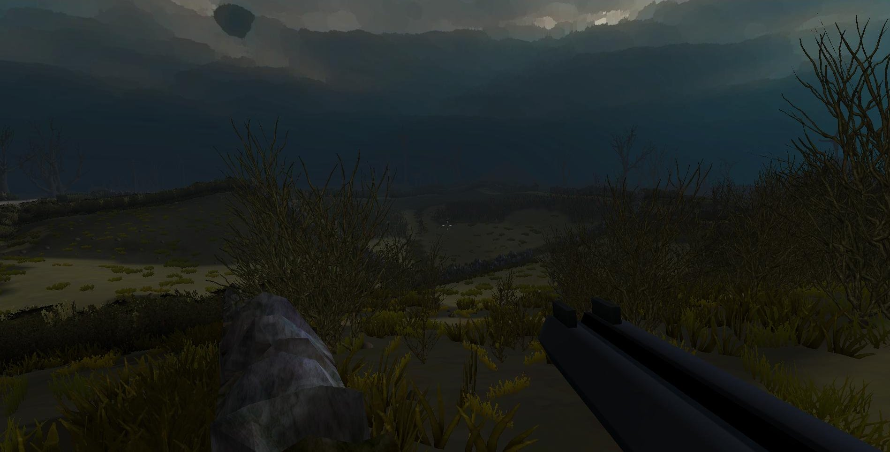

1. Example of a generated level in “Sir, you are being hunted” [15]

### Room-based Procedural Generation in Diablo 3

Games such as Diablo 3 implement a room-based generation system for a large part of their levels. Diablo 3 is a role-playing dungeon crawler game. It is focused on speeding through levels and exploration. The algorithm behind them manages to generate logically connected rooms and provide a unique sense of exploration for the player. There are static zones in the level, and borders for some of the levels are also static, but they are mainly used for elements such as quests that are part of the main storyline. The rest of the level is procedurally generated, and it may contain features such as side quests, treasure or other items that contribute to the level being different every time the player explores it. The idea behind static zones is to ensure that the players get used to places such as towns or quest givers. This ensures that the players do not get lost easily and still provides that randomness while replaying the game over and over again. Furthermore, the number of monsters and treasures throughout the level ensure that even if the player reaches a dead-end or find themselves in a loop, it will still be worth the time as they will get rewarded for exploring. However, the system was somewhat flawed as players quickly noticed how repetitive the levels were.

Hence the level generation system was updated with the release of a downloadable-content patch – Reaper of Souls. The new patch introduced a lot of new content such as new room models and levels but also a new mode in which the levels that were generated were not restricted by static components, such as components part of the main storyline. This new mode is called ‘Nephalem Rifts’. The result of that new mode is much more complicated and exciting levels. Furthermore, these levels are most likely generated as the player is exploring them. Since time is of the essence in them, the system is sending information to the player’s machine indicating which room should be displayed once they have almost reached it. This way the player does not stray from the path that leads to the end of the level unless they decide to backtrack. Moreover, it prevents any map tampering which was an issue in the game’s predecessor Diablo 2. However, there is a drawback with the generation system – the results depend entirely on how many room models the system is working with. When there is a lack of room models, the room repetition becomes quite apparent. There are certain types of levels for which this is the case. For example, while the player is progressing through the main storyline, they explore a place called “High Heavens” which consists of several levels. These levels do not consist of many room models. Hence when the system is using rooms from that level type, it is limited to only those rooms and the rooms start repeating. Additionally, the “rift” can be an exact copy of a level that has already been made – it is part of the main storyline levels.

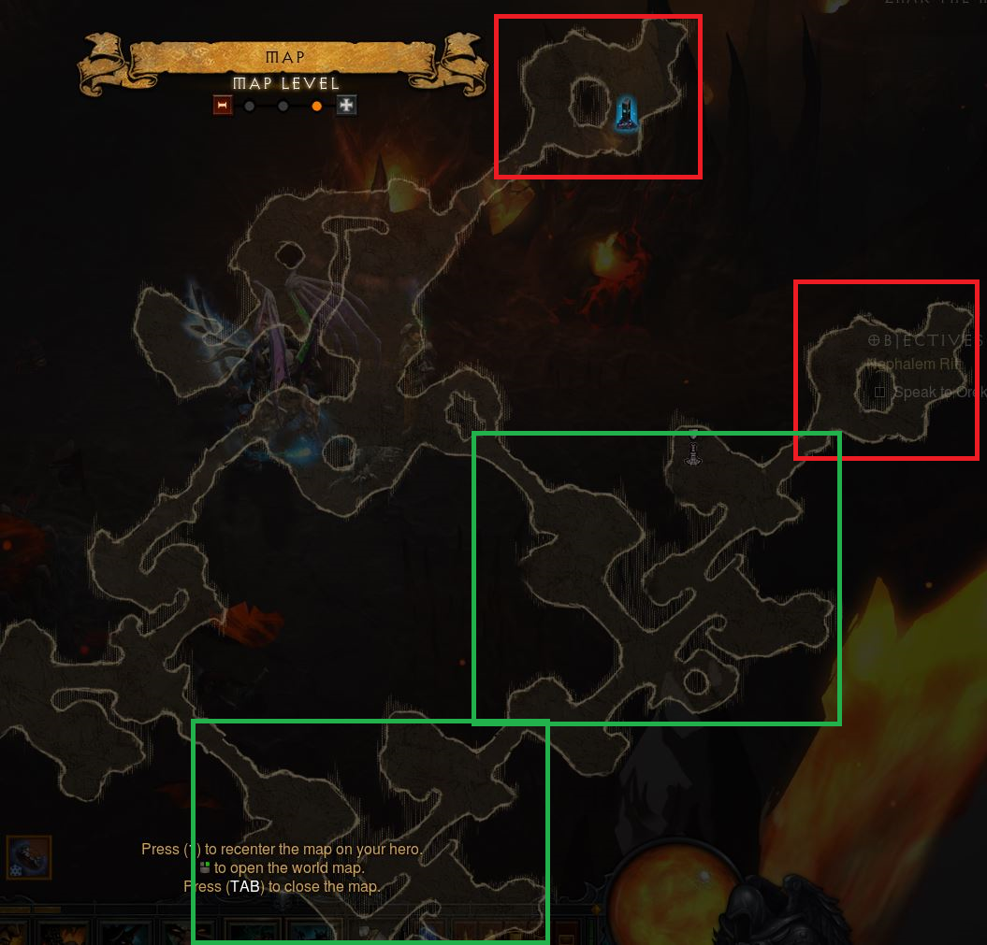*The screenshot shows the repetition of rooms in a “Nephalem Rift” level – marked in Red/Green.*

### The Procedural Generation Technique Behind the Game Path of Exile

Another game that is quite popular and rivals Diablo 3’s procedural level generation is Path of Exile. Path of Exile is an online role-playing game similar to Diablo 3. In the presentation [34] by the games’ lead programmer Jonathan Rogers, he explains the idea and approach taken behind the development of the game. They use two methods for generating the levels in the game: a room based generator used for indoor dungeons and an outdoor generator.

The room based generator works by combining rooms to form the dungeon level. There are a set of rules that the generator follows to guarantee that there will be a path from the start to the end. After dividing the available level space into smaller rooms that are the sizes of the rooms, it then uses the shortest path between the entrance and exit rooms by going through the least difficult rooms. This, however, only sets up the level with a single path and does not provide an exploration opportunity for the players. To improve on this, the generator uses the branching factor on each of the rooms and then it expands the level by adding several more rooms along the main path. The room based generator is used for indoor dungeons as it lacks the ability to create outdoor or organic shapes.

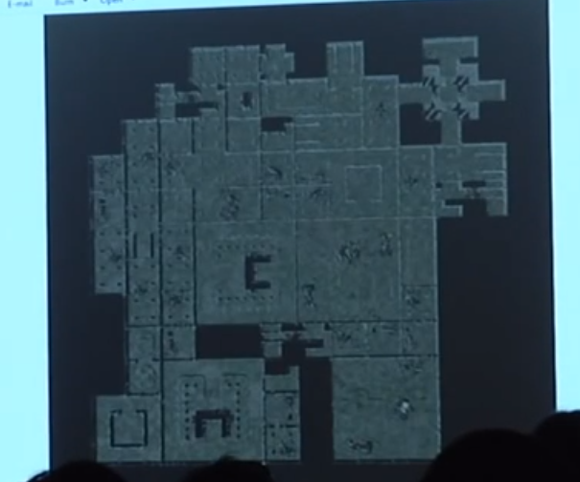

1. Screenshot of the presentation by the game's developers [34]

This screenshot shows one of the possible level maps in Path of Exile generated by their room based generator. It also shows the blocks the level is made of, and it does not look organic. Hence, a different approach is required when generating outdoor levels as the player will be exploring the areas near the edge and having a straight line will not be a pleasant experience.

To generate outdoor levels, the approach taken by the Path of Exile programming team at that time was different from how the room based generator was done in order to create more realistic and organic levels. The way this is achieved is by using a fractal algorithm to create an organic line for the roads, walls and other formations such as rivers. The tiles would then be placed along those lines. What this means is that the tiles would also have to be modified to have three or more possible connections on each side to accommodate for the different angles.

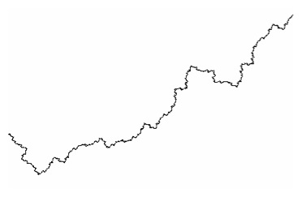

1. Fractal Coastline [35]

This image is an example of how the algorithm will generate a fractal line to be used in the game. The line is partially fed into another algorithm that transforms it into a Bézier curve and selects a tile based on the curve. This results in a more realistic level and it being random every time the player goes through it.

Generating rivers in a level takes a similar approach. However, rivers have two sides – they are not just a line, but they have two shores/two sides - so that must be taken into consideration as well beforehand. After generating the fractal line that will be the river in the level, that line is then split into two with space in-between. The lines then go through the same process and are rounded, so they don’t have sharp edges. The same algorithm is used on roads. Sometimes the road will intersect with the river or some other formation. Whenever that happens, the intersection between the road and the other formation is replaced with an appropriate tile such as a bridge tile or crumbling wall that the player can go through. There are many more options for those tiles depending on the situation and the level design. It a similar approach to the one Blizzard have taken in Diablo 3.

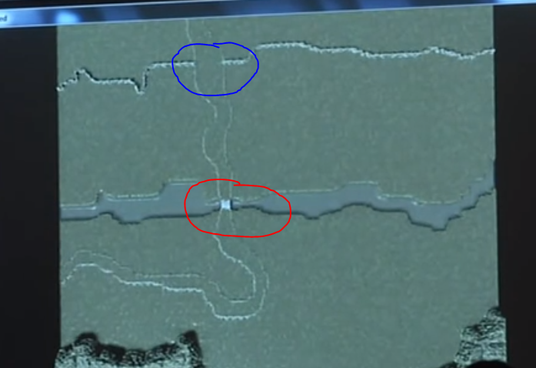

1. Screenshot of the systems outdoor level generator. [34]

In the image above, the red circle is where the path goes over the river, and that intersection will be replaced by a bridge tile. The blue circle is where the path goes through a mountain/wall, and the tile that they intersect at will be replaced with a broken wall or a passageway depending on the type of obstacle. It shows how they have tackled the problem of not being able to generate organic shapes with their room based generator, but also, they have taken into account that there will be areas that will intersect with different tiles and will have to be dealt with.

### Procedurally Generating Levels in the Video Game Warframe

Warframe is a cooperative Third-person shooter game in which players find themselves in the distant future playing as an ancient warrior. They are put against countless enemies in each of the mission levels, which are procedurally generated. For the generation of the levels, a room-based approach was used. For this purpose, each level is comprised of at least 30 different rooms of varying sizes that are connected to each other to form. The level room models are different in style and theme for each level. The game features around 22 unique room sets. Coupled with the fact that some, if not most, of the room models feature dynamic elements. These elements can range from moving objects such as cargo containers, which players can climb onto, to randomly placed static objects such as lockers, in which players can find treasures. Furthermore, each level might have a what is called ‘Environmental Hazards’. These hazards are essentially negative effects on the players or more dangerous rooms. As a result, the procedural generation system gives players a different level layout every time they play through the mission.

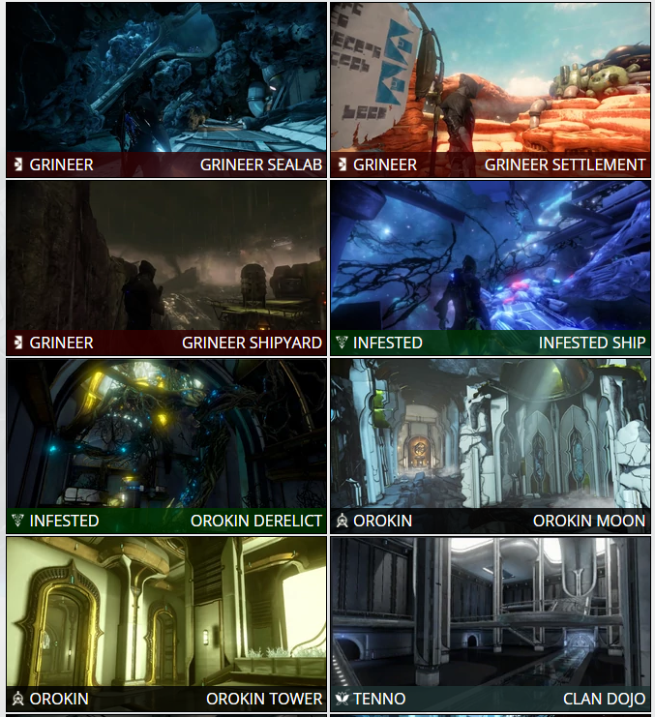

1. Some of the styles/themes for each of the room sets in Warframe. [36]

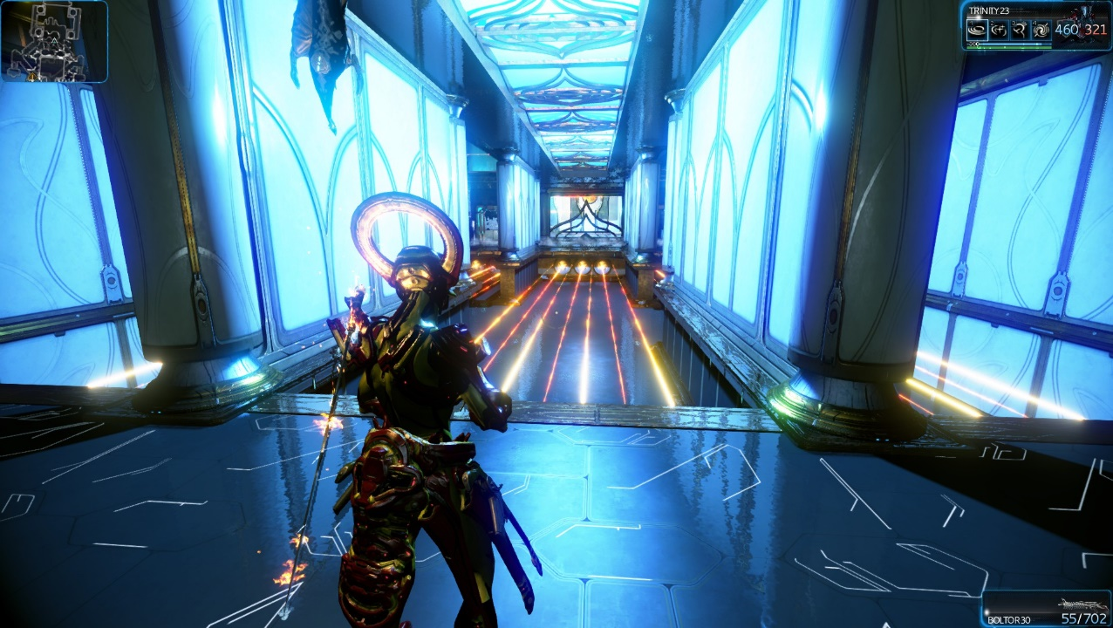

1. Example of a generated level using ‘Orokin Tower’ room set.

Warframe offers quite an excellent example of good procedural content generation. One of the reasons why it has been one of the top played games for a while on the digital distribution platform ‘Steam’. However, the levels the system generates have a few drawbacks. They are always comprised of a straight line between the start and the finish of the levels. To put it differently, there is only a single path from the beginning of the level to the finish. It would benefit from having loops or multiple ways of getting to the exit room. But this would come with other issues as the room models would most likely have to be modified to an extent to accommodate for that.

In any event, the techniques and methods behind the levels in the game are something to be kept in mind when developing a system like this one. Moreover, the game is continuously being updated and improved.

### Generation of Worlds Made of Blocks in Minecraft

A different approach to procedurally generating world levels can be seen in various other games. One such example is the sandbox game Minecraft. It is a 3D procedurally generated game world that uses blocks as the building materials of its levels. The goal of the game is to explore and gather resources which can be used to construct other structures or items. It creates different “biomes” or regions, in the world such as sand biomes, snow biomes and other several types of biomes – figures 1, 2, 3 and 4. These zones are how the game world in Minecraft is separated and adds to the feeling that the player is exploring vast lands and seas. Moreover, in each biome, there could be caves underground or within a mountain, which make every level feel unique.

For the generation of these worlds, the game uses “scaled 3D Perlin noise with linear interpolation”[3]. Perlin noise is an algorithm that generates a sequence of pseudo-random values. By combining it with a linear interpolation function, the noise that is produced has a smoother transition between the values thus producing a more organic shape. Using a 3D grid for the algorithm allows the ground height to be in a range of values and thus creating formations such as caves or mountains. Consequently, the biomes that can be seen in the game are built using a Whittaker diagram, which is basically a way of dividing up the procedurally generated landscape. It uses two abiotic factors, precipitation and temperature, to distinguish between different types of biomes. Furthermore, the dungeon generator in Minecraft makes use of ‘seeds’, which essentially ensures that when the same seed is used, the same world will be generated. However, while it does provide a seemingly random world every time, each of the biomes follows specific rules and those rules restrict the randomness. On the other hand, the reason behind that feature might be to provide the player with structures – temples, mountains, caves – to explore in each of the biomes.

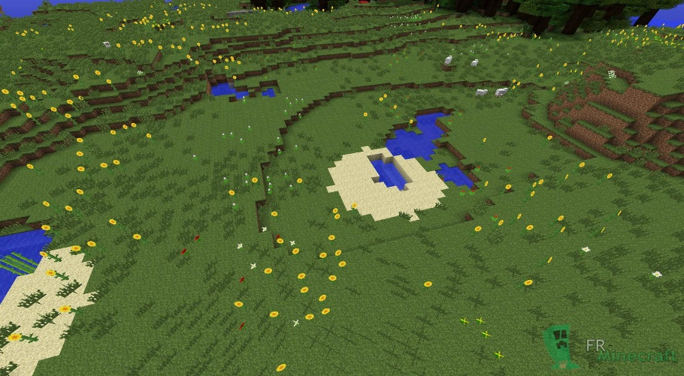

1. Plain/Grass biome [11]

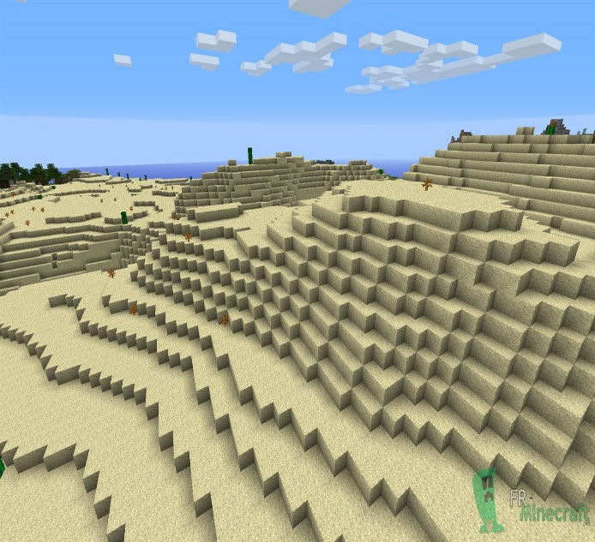

1. Sand biome [10]

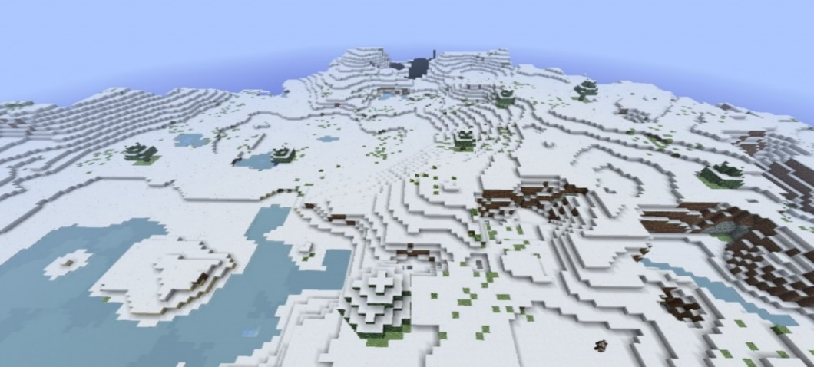

1. Snow biome [8]

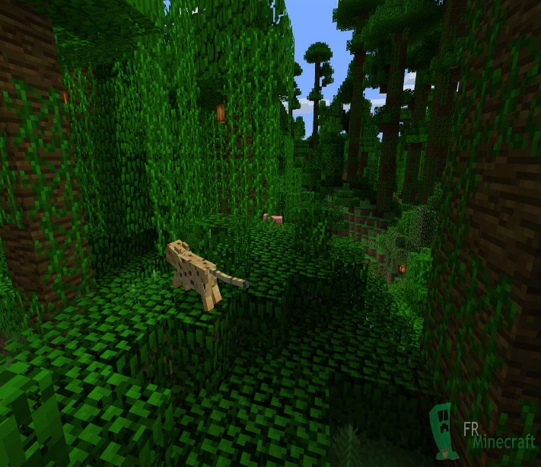

1. Jungle Biome [9]

### Generation of unique items in Borderlands

Other games such as the Borderlands series use procedural generation techniques when it comes to their in-game items. The system generates random items every time. The way the system was designed is it makes several random choices when determining the type of loot and then what its properties will be. When the player kills an enemy, the system picks from a list of possible item type lists – weapons/gear/vehicles.

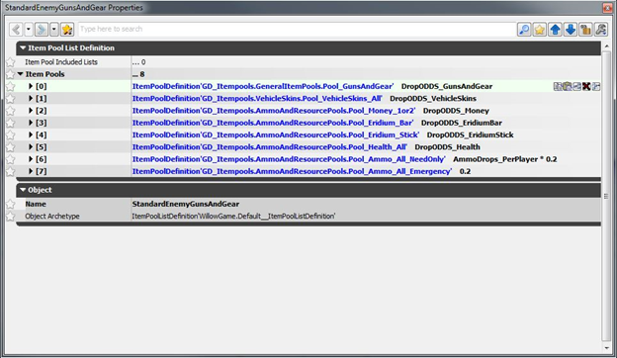

1. The lists the system chooses from when an enemy is killed. [4]

It then randomly chooses an item, which would most likely be another list, from the previously picked list. This process repeats until an items’ properties are built. However, whether an item drops from a list is determined by its chance of spawning. The system picks a random number between 0 and 1 and then checks against the items’ probability of spawning. If the number the system generated is less than the items’ drop chance, only then will the system generate an item from that list.

The game supports cooperative gameplay between up to four players. This feature exposed an issue with the system – it spawned too many items. In turn, leading to a tedious and overwhelming experience for players, as there would be too many items to choose from and sort out. Hence, the system was modified to reduce the spawning chance of items, but at the same time, the chance is increased the more players you have in the game. This change resulted in a more balanced system for both the singleplayer and cooperative experiences. There are also other features such as limiting the items that can be dropped by enemies or treasure chests at different stages of the game which aims to enhance the experience for new players, giving them time to learn the item properties, instead of getting overwhelming them with many new and unfamiliar properties and items. To sum up, the procedural generation system in Borderlands 2 generates unique and creative items using a wide variety of items and properties – for example, a pistol shooting rockets. There is an excellent diversity even when it comes to the same item in the game, which is one of the reasons behind the game's success:

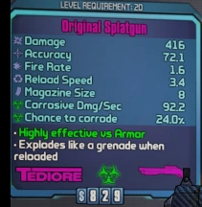 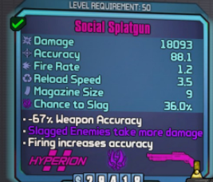

1. Same weapon but completely different properties.

### Generation of planets in “Outtera” and “No Man’s Sky”

Many other games creatively use procedural content generation to build their game worlds. Almost none are open source or can be used to create a whole new video game with the algorithms. However, there is one software product that takes procedurally generated content to the next level. This product is capable of generating entire planets from space all the way down to the surface, doing so with high precision. The name of the software product is Outtera, and it is a 3D rendering engine with unique rendering capabilities. It uses fractals to create the terrain. “The term fractal describes a broad set of shapes. Fractals are frequently used in procedural content generation because self-similarity seems to mimic natural processes such as erosion and plant growth.” [7]

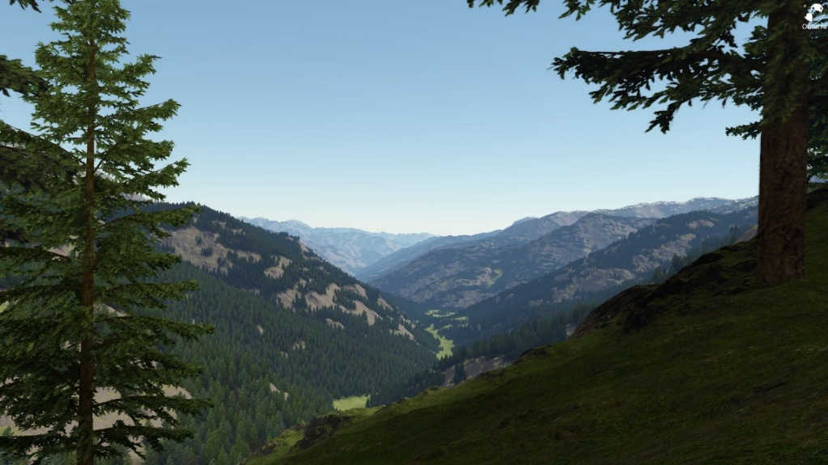

1. A close look at a forest generated by the Outtera Engine [12]

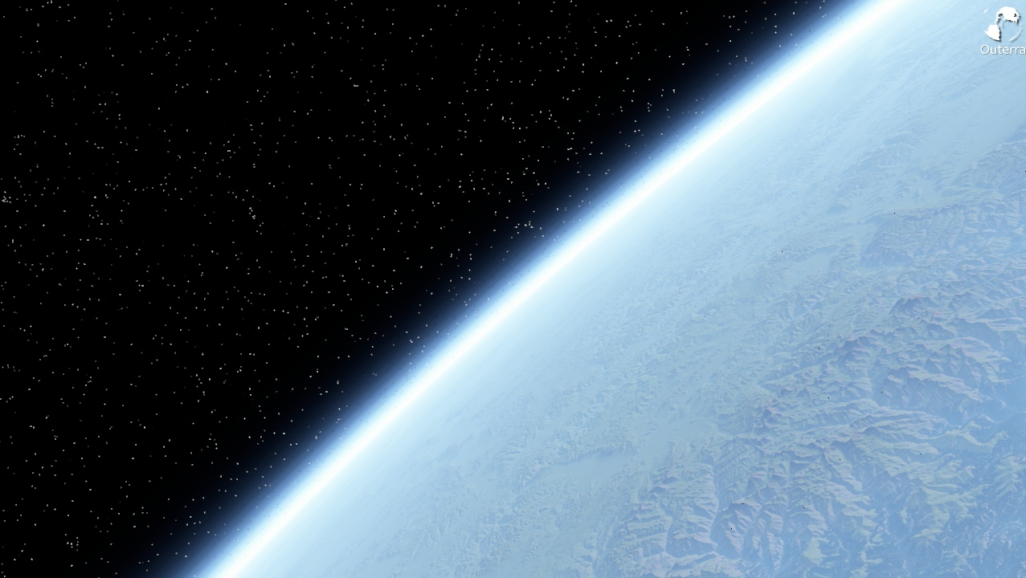

1. The generated planet Earth [12]

Another product that also makes use of Fractals and generates whole planets is the game “No Man’s Sky”. In it, players explore a procedurally generated universe which consists of over 18 quintillion unique planets. Despite having that many planets, the planet patterns can quickly become evident as the players keep exploring new planets. This, however, is one of the first games that use procedural content generation on this scale and it is quite impressive. There are more features and algorithms that are used to in both Outtera and No Man’s Sky that contribute to their incredible worlds.

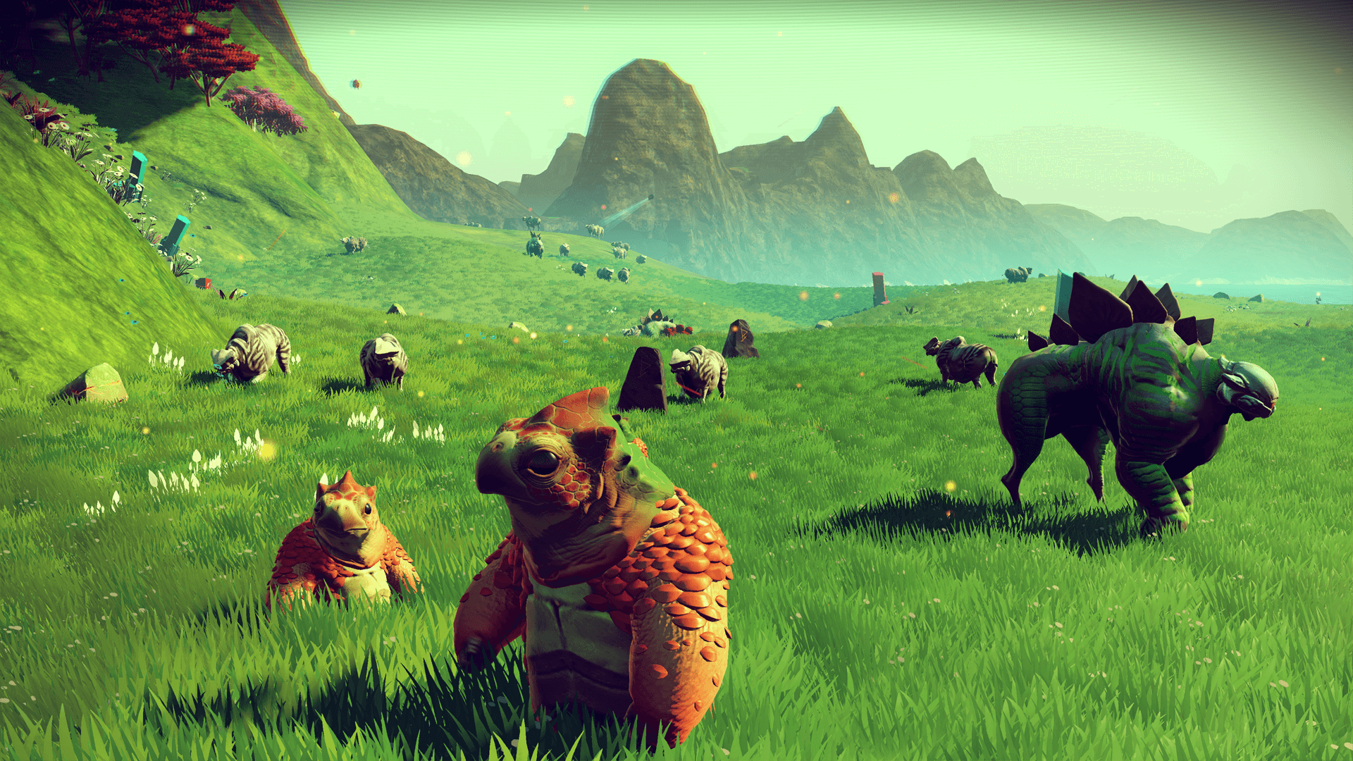

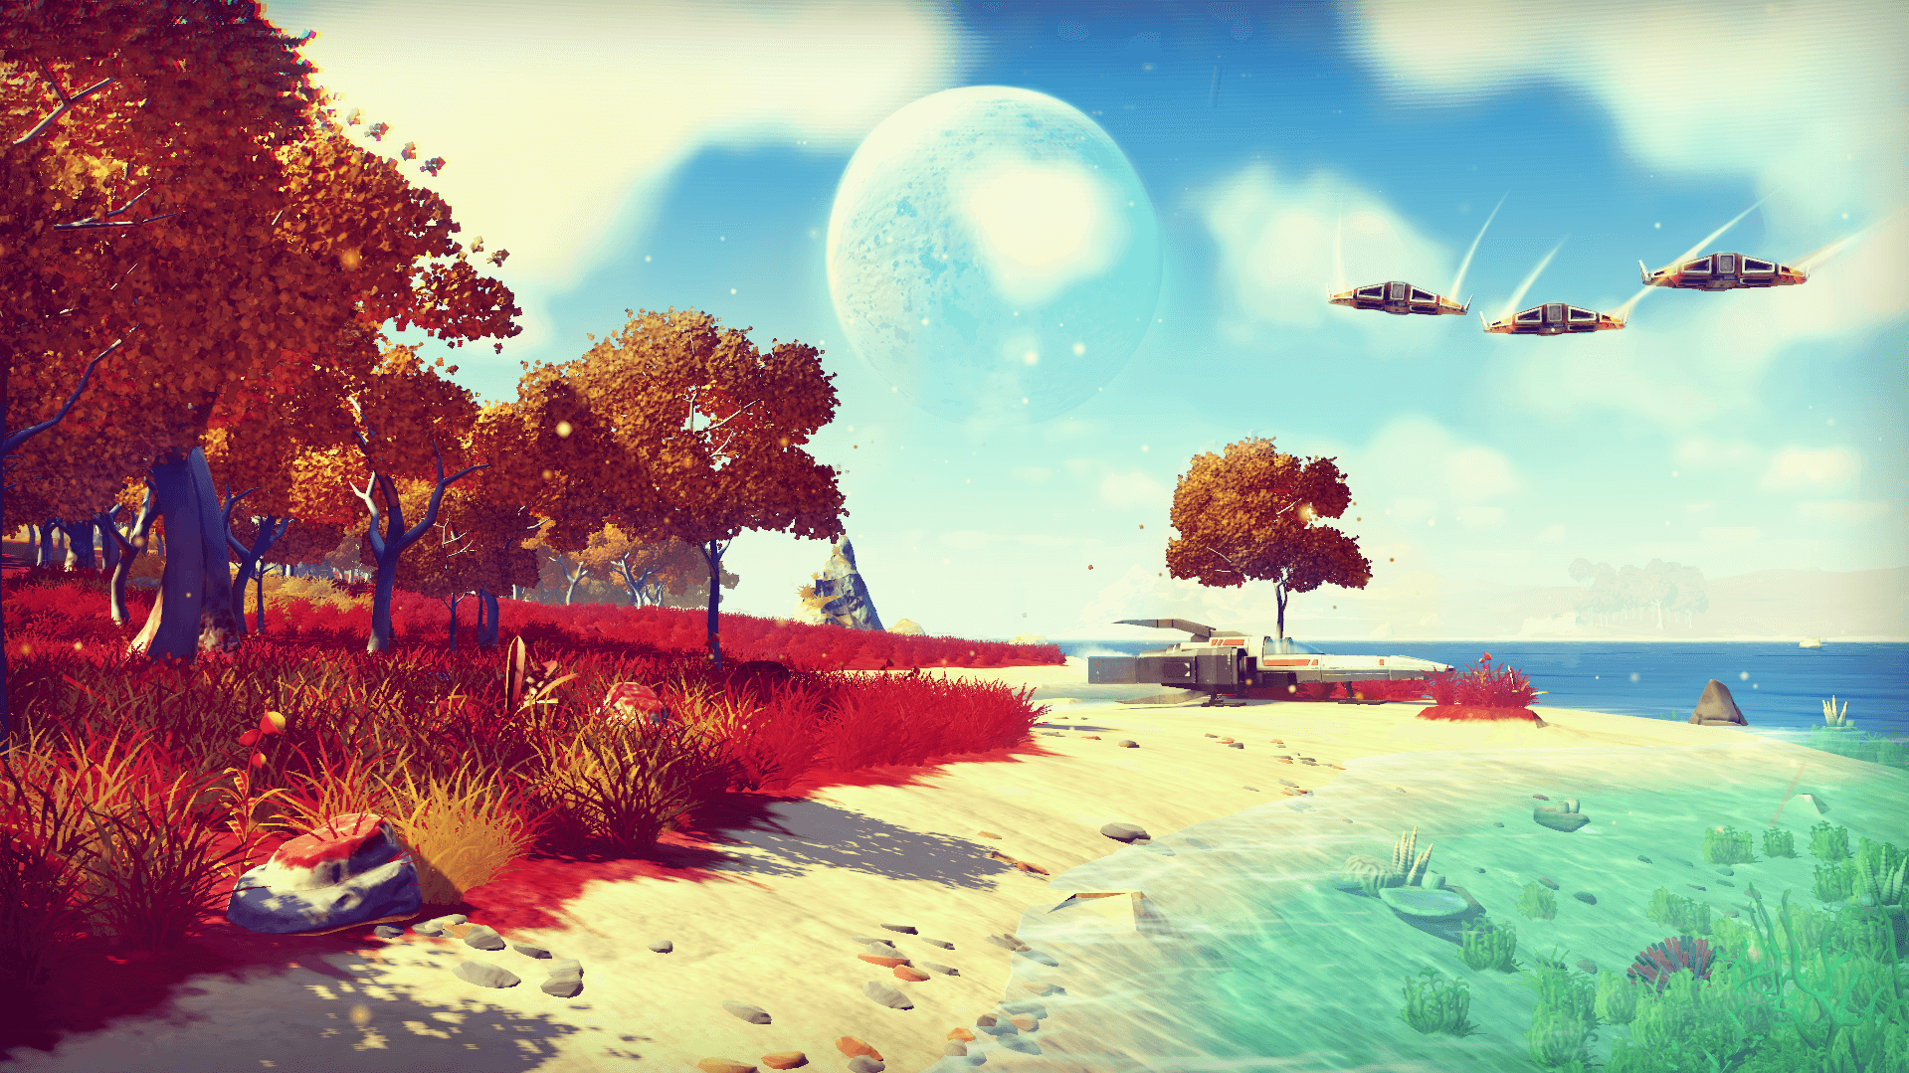

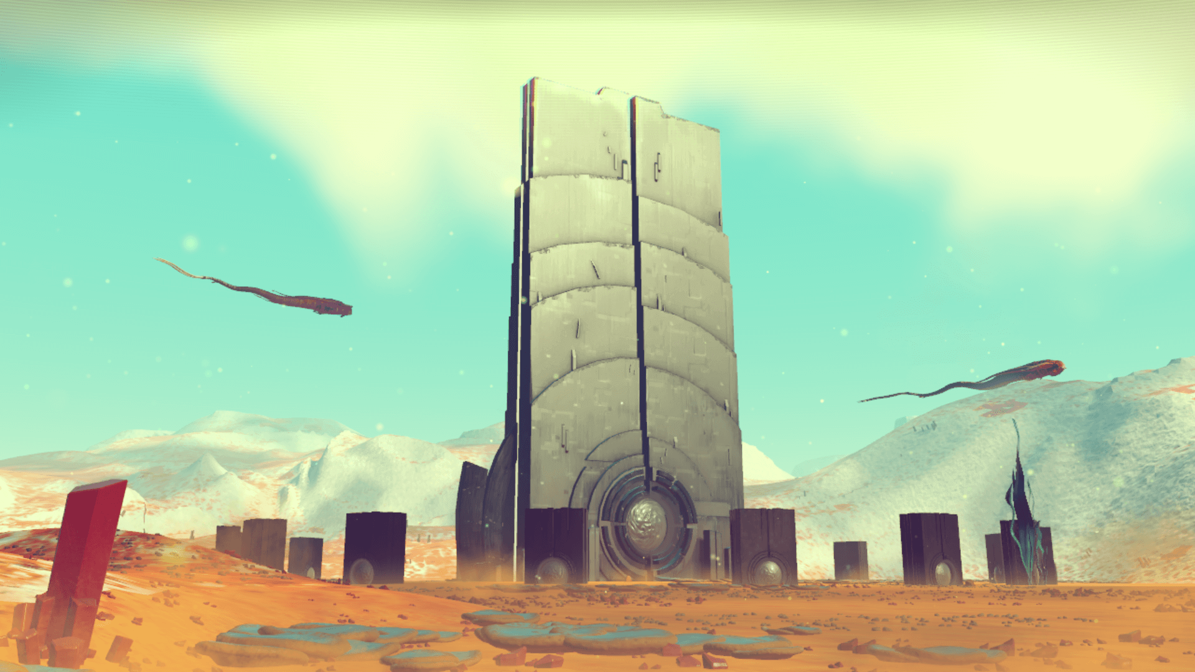

1. Screenshots of planets in No Man’s Sky [13].

For the development of the game, the developers have used what they call ‘Uber Noise’which is a unifying method of noise generation. It is essentially combining different noise algorithms to create a more realistic feeling to each of the procedurally generated worlds that the player can visit. Uber noise is multi-layered. It uses generated noise by algorithms such as Perlin and Simplex and layers the generated noise on top of each other. The system basically uses layers on top of layers of noise. Having multiple layers stacked produces much more organic terrain such as mountains and hills with smoother slopes. But also makes more diverse worlds as well. Moreover, uber noise makes use of a mix of 2D and 3D noise which contributes to generating cave systems and caverns in the worlds.

## State of the Art Summary

Procedural generation has many applications – not only the ones that have been discussed so far but many more. It can be used in various fields – games, art and even music. There are many techniques and algorithms and examples on the Internet that can be used to achieve different results. However, most of those examples offer incomplete solutions or provide poorly written code.

The techniques discussed in this chapter have their own advantages and disadvantages. Game companies have found ways to utilize the advantages of those algorithms and have implemented them into their games – either by combining various properties of the algorithms or by modifying the algorithms to suit their purpose. However, how procedural content generation is used in those games is kept secret. While it is understandable, it does not provide any guidance to people who are interested in the subject. Hence, this project aims to provide a starting point for people who would like to use procedural content generation in their applications. More specifically, this project focuses on dungeon generation and aims to provide users with the opportunity to expand the level generator into their video games. It can also be used as a base to build a more advanced dungeon generator.

# The Procedural Level Generation System

## Engine and Programming Language

The project system is built using the game engine Unity3D. It was chosen over other game engines such as Unreal Engine 4 and Amazon Lumberyard for its friendly user interface. Subsequently, the Unity engine provides users with a variety of assets in its Asset Store. Despite having to pay for some of them, the user can easily download and incorporate those assets in the dungeon generation system to design a richer visual level experience. The engine also allows users to build and deploy the project to multiple platforms quickly. The Unity3D engine gives users an option between three programming languages when it comes to creating scripts – C#, UnityScript (JavaScript for Unity) and Boo. The C# programming language was chosen for implementing the scripts necessary for the procedural content generation system to function. It was chosen over UnityScript as it better supports the data and structure types that are needed for the development of the project. Moreover, Unity Script is not the same as JavaScript. Also, it has less documentation and examples of being used for game development. C# was chosen over Boo as the Boo programming language is now deprecated and it is used by a small percentage of people in the Unity community. Thus making it hard to research and gather information about programming in Boo.

## The Idea Behind the Implemented System

The idea for the project was inspired by Marcin Seredynski [7] who uses a room-based approach for generating a dungeon level. The system that was implemented as a solution for the task at hand uses a similar generation approach, making use of user-supplied room models. However, before the system can use those models in the procedural generation algorithms, it first needs to know more about the rooms. In addition to allowing users to set up each of the components that are used by the system, the user interface provides a quick and easy way of reconfiguring the algorithm parameters that the system uses when generating levels. The user interface not only lets users specify the type of room each room model is, but also which room type can be connected to which other type. The system then uses all of the information that has been provided in combination with various classes, part of the Unity engine, to procedurally generate a 3D level with one entrance and one exit.

## System Implementation

### System design

The system is designed to use imported models to generate dungeon levels. The models are created in a 3D computer graphics software such as 3DS Max or Blender and are then exported and imported into the Unity3D engine. The idea behind this approach is to give users and developers a more creative solution when it comes to creating the models they would like to use. As Unity does not provide art features, this approach provides the opportunity for more complex and intriguing room models to be created.

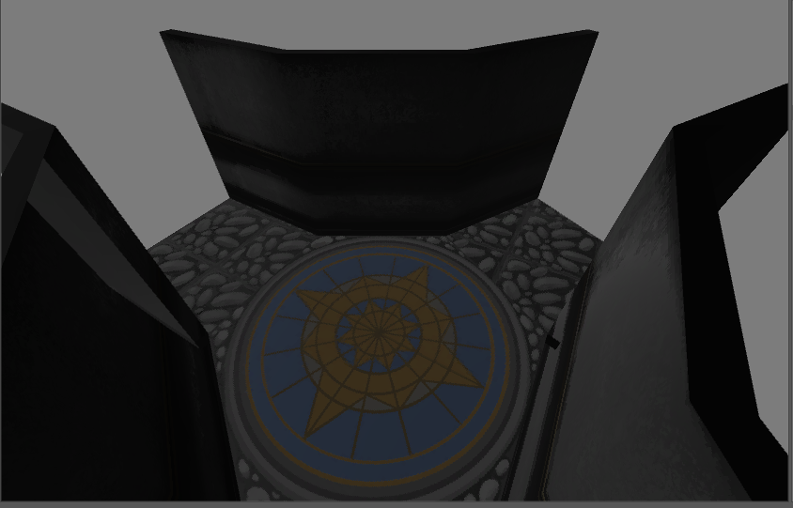

1. Example of a room model that is textured and imported into Unity3D.

As can be seen from the example screenshot above, giving users the ability to import their room models which can have multiple elements such as cameras, lights and materials, can lead to incredible and creative models. The models, however, would have to comply with certain restrictions if users want to make full use of the system. In the figure above, the room model does not have walls or doors where the exits are. The reason behind this is to reduce the workload for users when creating the models. This feature allows users to create a single room model and several doors or wall models which the system will use and will dynamically create them at specific locations within the rooms. This not only reduces the workload but also opens the door for further extensions to these components. This topic is discussed in more detail later on in the dissertation. The next chapters focus on the coding side of the project and each of the system components.

### Algorithm Overview

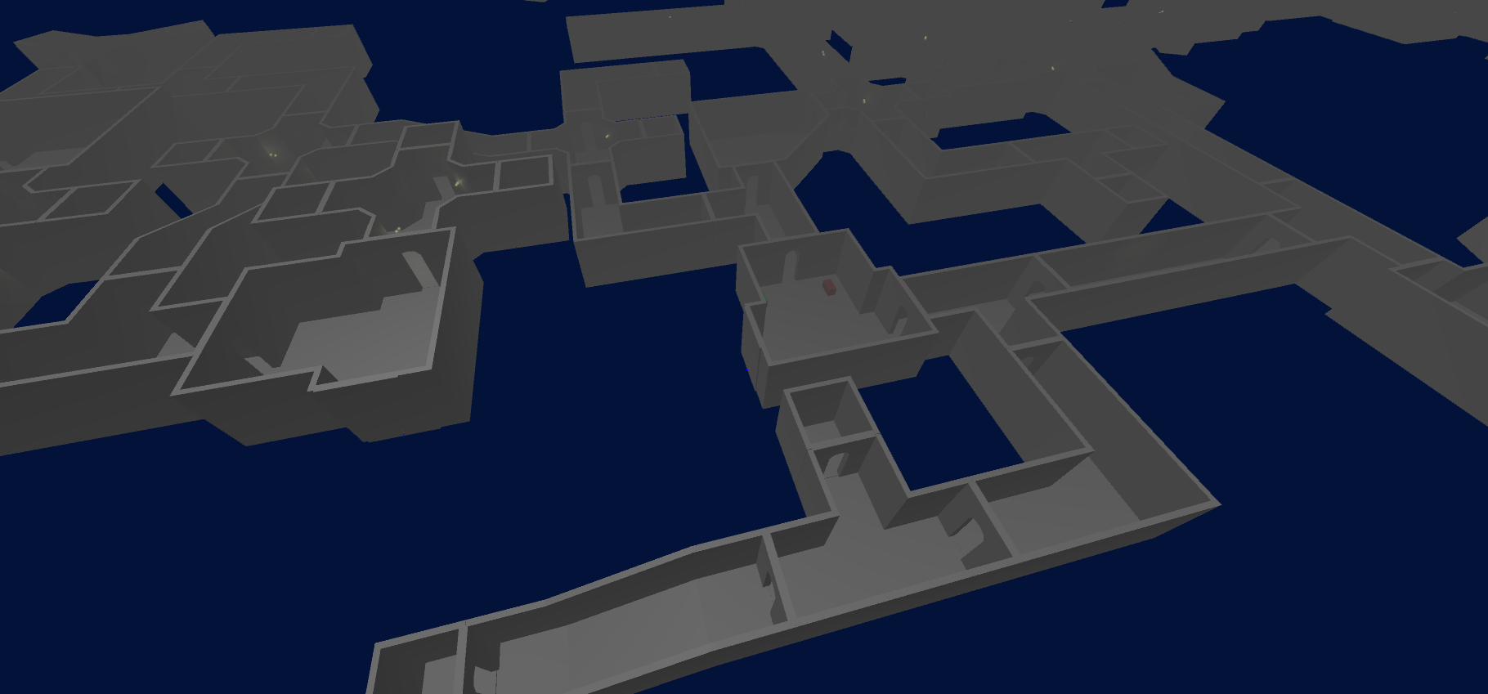

1. Part of a level generated by the system.

The system generates a dungeon level using room models supplied by users. Moreover, it makes use of various libraries and functions that are part of the Unity Engine. The implemented algorithm randomly places and connects rooms within the level and ensures they are not colliding by using those libraries. The sequence of rooms that are randomly picked is not entirely random. It is a pseudo-random sequence. The system uses ‘seeds’ to generate different sequences for every different ‘seed’. Hence, when the same ‘seed’ is used, the level that is generated will be the same every time. The use of a ‘seed’ can also contribute to reducing the information that needs to be saved when the player's progress within the level is saved – as only the ‘seed’ would have to be saved to regenerate the same level when the save is loaded.

Additionally, the system provides a user interface for each of its components. Allowing easy access to the inner workings of the scripts for developers. Each component is separated into its own script or class so they can easily be modified. Not only does this make the code more understandable but also every component, along with it’s most essential properties, have comments attached to them which are visible inside both the Unity Editor as well as in the code itself.

As mentioned above, each script and component has a single purpose and a role it plays when the system is generating levels. Those scripts and components are discussed in greater detail in the following chapters.

### The Level Generation Algorithm In-depth

The System generates a 3D dungeon level with parameters specified by the users. The generator script which is responsible for the generation of the level is attached to an empty game object in the Unity engine. This is where users can modify any of the parameters they would like to. Parameters, such as specifying the starting room prefab and its location and others, have been exposed to the engines ‘Inspector’ to allow users to quickly reconfigure the parameters of the algorithm without having to dive into the code. The Inspector allows users to view and edit the component settings for the selected game object. [16] To achieve this result, the private variables that are used in the algorithm had to be serialized using one of Unity’s Attributes – SerializeField. “It forces Unity to serialize a private field.” [17] Essentially, it exposes a private variable to the Inspector, so it can be modified from there. When the script is started, it uses the values that were set in the Inspector unless they have been changed in the code. This, however, does not change the access modifier of the variable. It remains private and cannot be accessed from another class without a public function to provide access.

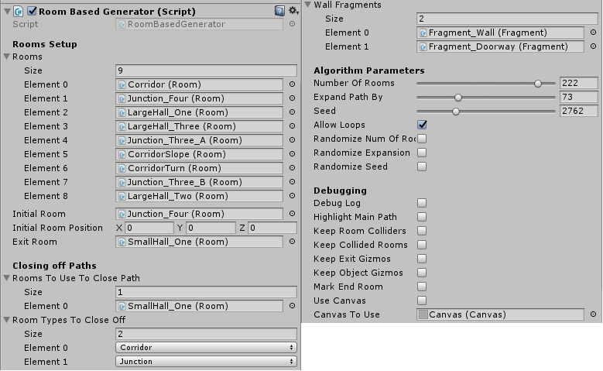

1. Screenshot of the serialized variables that the user can modify from within the Inspector

Before using the values that were set in the Inspector for the serialized variables, the algorithm checks them to ensure that the values can be used and will not crash the system. The ‘Rooms Setup’ section is where users can specify which room prefabs they would like the system to use when generating the level. Furthermore, users can modify parameters in the ‘Algorithm Parameters’ which determines how many rooms are created in the level – changes here are visible immediately after the script is run as the size and structure of the levels will change. The ‘Closing off Paths’ section is used to specify whether to add extra rooms to the level to make exploring it more rewarding – as there will be treasure chests/monsters in those rooms. This section is discussed in greater detail in chapter 3.3.8. Finally, the ‘Debugging’ section is to help users identify changes and see how the code works by making use of the booleans. For example, if the ‘Keep Room Colliders’ option is ticked, the colliders that were used to check if a room has collided with another room during the generation of the level will not be deleted after the level is generated. A step which is taken to reduce the CPU usage as those colliders are no longer necessary.

The system generates the level by first creating an instance of the initial room prefab at the specified coordinates. Then proceeds with expanding the level by attaching other room prefab instances which match the type the initial room can connect to. The system works with three room types – ‘Hall’, ‘Junction’, ‘Corridor’ – discussed in chapter 3.3.4 . For example, if the starting rooms’ type is ‘Junction’, which can connect to the types ‘Hall’ and ‘Corridor’, the system will randomly pick a room prefab with one of those types. It will then create an instance of it and attach the two rooms. This process goes on until the specified number of rooms has been reached. While the system is generating the main path of the level – from the starting room to the exit room – it will step through each of the rooms as it is adding them. If a dead-end is reached, the system will backtrack to the first room that has an open exit that can be expanded. Once the main path has been generated, the system then adds an additional number of rooms, specified by the user. These rooms are connected to already existing random rooms, ensuring the level is expanded from every possible exit, and not merely expanding only one path. After the level is complete, the system goes through all the rooms twice. The first time, it closes off any of the specified room types ensuring that room types such as ‘Corridors’ don’t simply end but provide the player with a reward for exploring it. The second pass through the rooms, the system adds ‘Fragment’ instances to fill in the gaps in the room prefab instances – further discussed in chapter 3.3.7 .

To sum up, the algorithm implements procedural content generation by making use of both the Unity engine and C# Random classes to generate a unique 3D level every time the script is run. It creates a path of rooms from the starting room and places the exit room after the specified number of rooms have been added to the level. This path is then expanded by a set number of rooms and any additional rooms if specified by the user. The whole process is accompanied by parameters that can be adjusted by the users via the Unity Inspector. Moreover, each parameter has a comment that is displayed when the mouse cursor is on top of it. The comments not only further contribute to understanding how the system, but also makes the system friendlier to users who might be new to either Unity or the C# programming language.

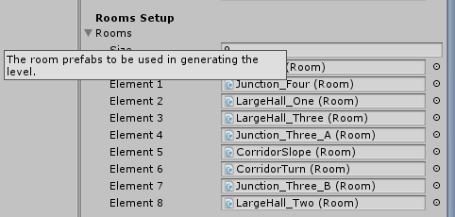

1. Comment that is displayed when users put their mouse cursor on the ‘Rooms’ text.

### Tracking Room Collisions

The system generates the whole level with a sequence of function calls within a function. This approach has its drawbacks. One of the most significant drawbacks is that the engines collision detection picks up collisions only after the level has been generated. When the scene is run, the level is generated during the ‘Start’ phase of the scene. Due to the physics cycles phase beginning after the starting phase, checking whether an object has collided with another, or in this case, if a room has collided with another room, is not possible by using the engines collision function ‘OnCollisionEnter’. “OnCollisionEnter is called when this collider/rigidbody has begun touching another rigidbody/collider.” [18] The same issue applies when the level is re-generated after already having been generated once. However, it is not entirely the same, but it suffers from the same drawback. In this case, the level is re-generated within a few frames. Thus the engine would register and report the collisions between the rooms at a slower rate.

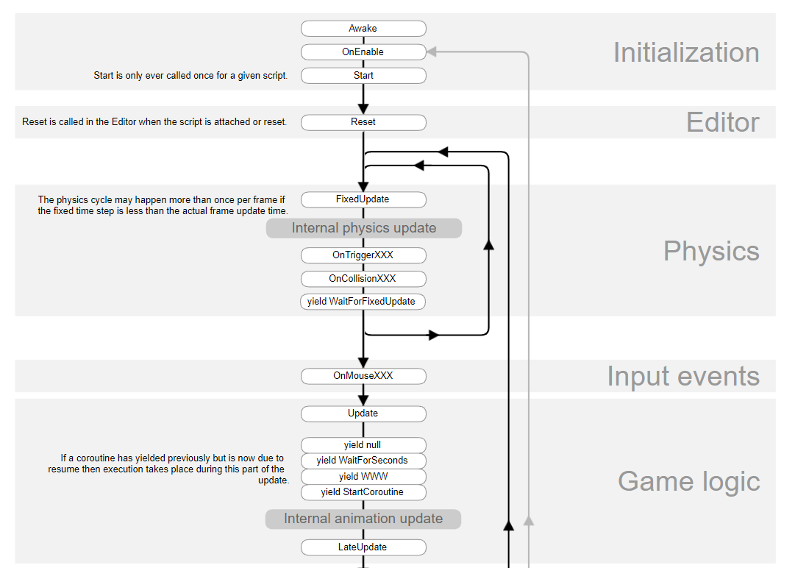

1. Part of the Script Lifecycle Flowchart in Unity3D [18]

Hence, a different approach was taken for detecting collision between the rooms in the level. For the purpose of detecting collisions, the engines Physics class was used to determine whether any colliders are touching or inside of the given simple object – box, sphere, capsule.

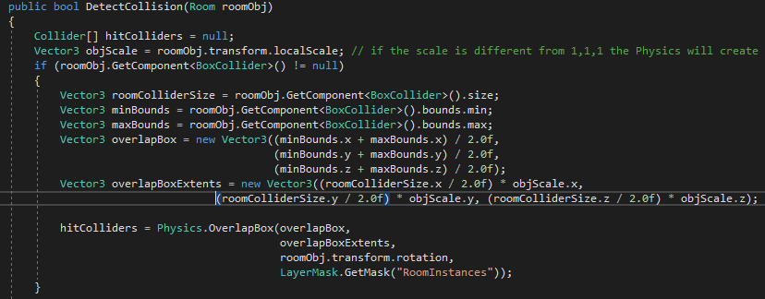

1. Example of how the Physics class is used to detect room collisions.

The example from the figure above shows the approach taken to detect collisions during the generation of the level successfully. However, for this approach to work, every room needs to have a collider component attached to it. The Unity engine calculates a quite accurate collider size and centre automatically when a collider component is added. This fact is used when setting up the room prefabs which is the point of discussion in the next chapter. The user can choose which collider type best fits the room and can also adjust the size/radius and the centre if necessary. In some cases where a sphere or capsule collider needs to be used, the engine does not correctly calculate the pivot point, and so the collider does not cover the room accurately. Hence, the user is allowed to manually override those collider settings when setting up the room prefabs.

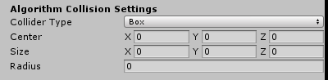

1. Setting up the collider for the room prefabs.

This, in turn, provides the algorithm with the necessary information to perform the collision checks. When a collision is detected, the room that is currently being added is marked for destruction – it is moved to the layer ‘Collisions’. Layers and tags are discussed in chapter 3.3.9. The collision detection function only checks for collisions in a specific layer – the ‘RoomInstances’ layer. Hence, any room object that is in a different layer will not be detected as a collision. Meaning, the collided rooms remain present in the level and may overlap with other rooms. Since they are in different layers, however, that is not an issue. The room objects and any other objects that are in the ‘Collisions’ layer are deleted when the ‘Update’ function is called. Thus the user will see a clear level without any overlapping rooms once a frame has passed and the ‘Update’ function has been executed. The layers system greatly contributes to solving the problem regarding the level generation within the ‘Start’ function that was mentioned earlier.

### Room Prefabs

Objects in the Unity3D engine are called ‘GameObjects’. They do not add any functionality but are simply holders for components such as Transform, Light, Scripts or any other components. A ‘Prefab’ is a reusable GameObject which is stored in the project. It can then be inserted into any number of scenes, multiple times per scene. A scene is where GameObjects are placed to make a game level. When a prefab is added into a scene, an instance of that prefab is created. “All Prefab instances are linked to the original Prefab and are essentially clones of it.” [21] Making a change to the original one applies that change to all of the prefab clones or instances that exist in the scenes. However, modifying the prefab clones does not modify the original prefab unless it is instructed to do so. This allows for spawning a generic version of a Game Object and at the same time allows for it to be modified without applying those changes to the rest of the same Game Object instances that are present in the scene. The system uses room prefabs to generate the levels. However, the room models are not prefabs.

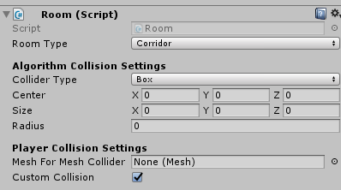

1. The exposed variables from the Room Script.

In order for the system to be able to connect the rooms that have been provided, it needs to know how and where they can be connected. This is where the ‘RoomConnector’ class comes in. It is used to determine the number and location of exits in a room. However, it is not the focus of this chapter and will be further explored in chapter 3.3.6. Game objects with the ‘RoomConnector’ script attached to them are used to define the exits in a room prefab. These objects are used by the system to determine where another room can be attached to this one.

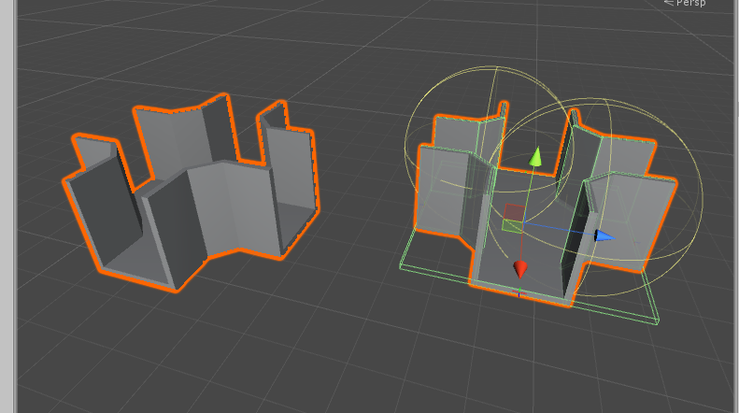

1. Screenshot of a room GameObject on the left and its prefab on the right.

The figure above shows a room model that was just added as a GameObject into the scene, and an already set up prefab of that object on the right. The prefab has all of the components that were mentioned earlier – colliders for player collision, light sources, room connector game objects and scripts.

Apart from classifying the room models as room game objects, the ‘Room’ script also keeps track of the exits in the room – whether they have been closed, connected or still open. It also provides access to each of the exits. The script is also used to set up the colliders needed for the collision detection and is responsible for destroying them after the level has been generated. This approach was taken to support future changes to the script as this way every room object takes care of itself allowing changes to specific rooms. Additionally, the script holds an essential part of the algorithm – an enum class defining the room types. “Enumerations allow you to create a collection of related constants.” [20]

/// <summary>

/// Defines the types of rooms.

/// </summary>

public enum RoomTypes

{

Hall,

Corridor,

Junction

};

[SerializeField] private RoomTypes roomType; //the type of the room

1. Defining the room types in an enum class

Using the enum class for the purpose of keeping track of the room type makes the solution scalable. When information is retrieved regarding the room type, the constants in the enum class are used, instead of strings for example. Hence, when adding more room types, only the enum class would need to be updated, and the system will still function successfully.

### Room Connection Rules

The ‘ConnectionRules’ class serves only one purpose. To help the user define the connection rules between the different room types. It retrieves the possible room types from the enum class discussed in the previous chapter.

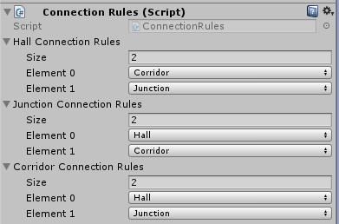

1. ‘ConnectionRules’ script exposed variables.

The system then uses this information to decide from which pool of room type to pick a room and add it to the level. On the off-chance that the user does not specify any connection rules, the system resorts to using the default connection rules. This is done in the ‘Awake’ function of the ‘Initialization’ cycle to ensure that the connection rules are set before generating the first level in the ‘Start’ function.

/// <summary>

/// Use default connection rules if none have been set up

/// </summary>

void Awake()

{

if (hallConnectionRules.Length == 0)

hallConnectionRules = new Room.RoomTypes[2] { Room.RoomTypes.Corridor, Room.RoomTypes.Junction };

if (junctionConnectionRules.Length == 0)

junctionConnectionRules = new Room.RoomTypes[2] { Room.RoomTypes.Corridor, Room.RoomTypes.Hall };

if (corridorConnectionRules.Length == 0)

corridorConnectionRules = new Room.RoomTypes[2] { Room.RoomTypes.Hall, Room.RoomTypes.Junction };

}

1. System using default connection rules if none have been set.

### Room Connections

In order to give the system information regarding the exits in a room game object, the ‘RoomConnector’ class was implemented. It stores information about an exit in the room – location, rotation, the collider settings that are used to form loops in the level. It provides the user with an indication of where the exit is currently located using the ‘Gizmos’ class, which is part of the Unity engine. “Gizmos are used to give visual debugging or setup aids in the scene view.” [19]

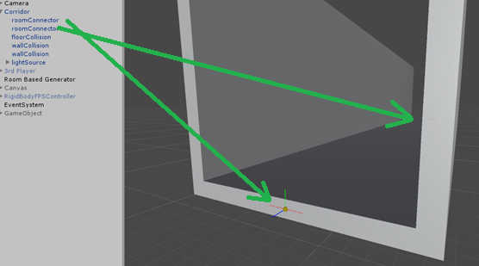

1. Showing the ‘gizmos’ which are the small spheres indicating the exits position.

Having the coordinates of where another room can be attached, the system uses a function to match the two exits – the exit of the room that is in the level and the exit of the room that is being added. The azimuth is the angle formed between a reference direction and a line from the observer to the point of interest projected on the same plane as the reference direction orthogonal to the zenith.

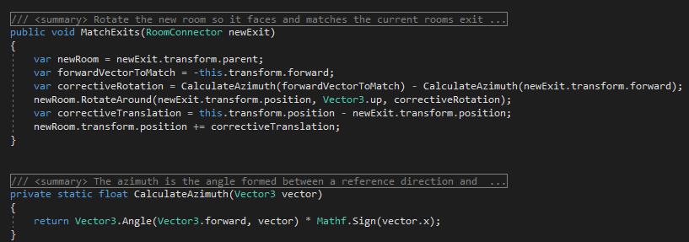

1. Calculations for correctly rotating and attaching one room to another.

Keeping track of the information regarding the exit of the room required the implementation of an additional class for that purpose. Hence, the class ‘RoomExit’ was implemented to store the information that is essential to the system. Every instance of that class holds a reference to a single exit. Furthermore, it keeps track of information such as whether the exit is still open, has a fragment been spawned at its location and whether it has been connected to another exit including the exit object itself it is connected to. The system uses this information to determine not only which rooms have open exits, but also when adding fragments to the level along with any additional rooms to close off paths. Keeping this information updated through the generation of the level is of high importance as it guarantees the system won’t try to add rooms to an already connected or closed exit.

### Fragments

Fragments represent pieces of the room models that are added dynamically. The idea behind this is to give the users a more flexible alternative when it comes to designing the room models. Having to design multiple small pieces that fit a room model instead of multiple rooms for each different doorway is less tedious and time-consuming. Hence, the ‘Fragment’ class was created to suit that purpose. Fragments are referenced in the level generator script which requires a prefab with the ’Fragment’ script attached. This tells the system the number and types of fragments it has available to use for the dungeon generation. The system spawns the fragment prefab on top of the ‘RoomConnector’ component which may cause issues depending on how the fragment model was designed. For this reason, there are additional settings exposed in the Inspector to let users adjust the position they are spawned at. It also allows users to rotate the fragments by an additional degrees value on the ‘Y’ axis. Fragments of type ‘Door’ are placed on exits which have been connected to other rooms.

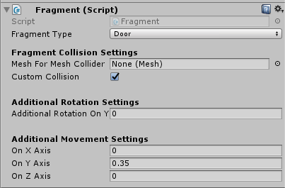

1. Exposed variables to adjust the fragments.

This is where the information stored in the ‘RoomExit’ object instances is used as well. However,the system initially spawned a fragment on top of each of the connected exits, and thus they overlapped. Fixing this issue required a Boolean flag variable to be used which is set to true if a fragment is spawned at either one of the two connected exits.

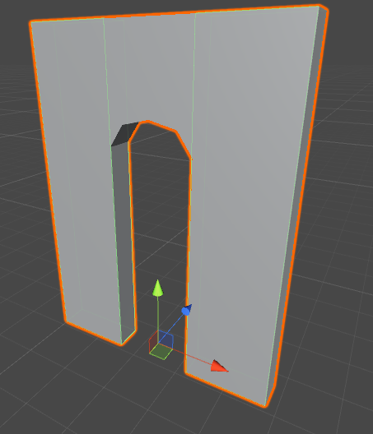

1. Example of a door fragment.

Furthermore, when the system has to place a fragment between two rooms that are connected, it will randomly pick one of those exits and place the fragment there. This, however, may lead to slightly odd looking connections due to the fact the doorway might be placed within the next room the player explores. Hence, the ‘RoomConnector’ script offers developers the option to set an exit to have priority. What this does is it tells the system to always spawn the fragment on top of this exit when it is connected to another room.

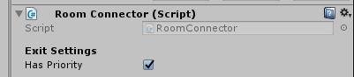

1. The ‘Has Priority’ variable that determines whether a fragment is always spawned on top of this exit instead of randomly between this and the connected.

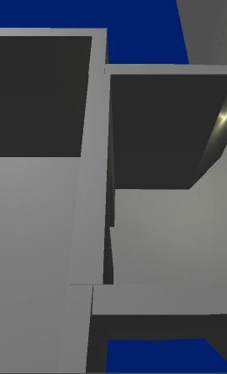

1. Screenshot of two connected rooms – ‘Hall’ type and ‘Junction’ type.

The screenshot above shows the fragment has been spawned on top of the ‘Hall’ room and contributes to the level looking more natural. The configuration for the exit in the ‘Hall’ room in this screenshot can be seen in Figure 14. Hence, a fragment between this room and another will always be spawned on top of this exit, unless both connected exits have priority - in which case the system chooses randomly.

### Making exploration worthwhile – ‘Closing off Paths’

One of the elements that make a dungeon level good is the sense of reward for exploring areas that are not part of the main path. The system implements this feature by adding additional rooms to the level. This feature is optional. If it has not been set up in the level generator script, no additional rooms will be added to the level.

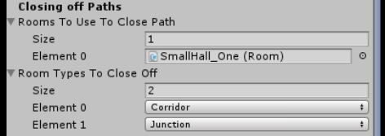

1. Settings for closing off paths.

If the user chooses to set the feature up, a room prefab needs to be specified along with to which types of rooms it can be connected. Having the feature implemented this way allows for a range of room prefabs to be selected by the user and then a random one is picked to be attached to a room in the level. However, these rooms still follow the same collision rules – if a room being added is colliding with another, it is not added, and the exit is closed. It is useful in cases where a corridor room – with two exits – is not expanded and essentially leads nowhere.

### Tags and Layers

Tags and layers in the Unity Engine offer a quick and efficient way of finding specific game objects. Tags “are marker values that you can use to identify objects in your project” [22] while layers are “groups of objects that share particular characteristics.”. [22]

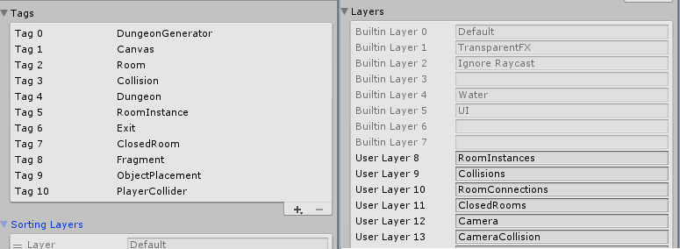

1. Tags and layers list.

Both of these features help the system find specific game objects with great ease. They are extensively used when keeping the data regarding rooms and exits up to date. Furthermore, layers play an essential role in the room collision detection functions as well. Having different layers for the different types of objects (Rooms, Exits, Collisions, Cameras, etc.) reduces the number of collisions the system detects. This is done by passing the layer, in which to search for collisions, to the physics function.

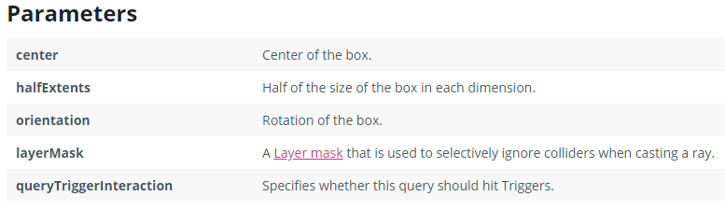

1. Parameters of the Physics.OverlapBox function.

As explained in chapter 3.3.3 the system uses the Physics class to detect collisions between rooms during the generation of the level. The ‘OverlapBox’ function is one of the functions that is used when the collider attached to the room is of type ‘Box’.

Room prefabs may hold a number of components including colliders for the room and the objects that are part of the prefab. This would result in false room collision detection. Hence, layers are used to separate the different components from the actual rooms. All instances of the room prefabs are added to the ‘RoomInstance’ layer which is then referenced in the physics functions, guarantying that only the rooms themselves are checked for collisions, and the rest of the objects in the level are ignored.

### Player Collision

The implemented system gives users two approaches when it comes to setting up the room-player collisions. The first approach uses collision meshes - a simplistic 3D mesh version of the room model that is used by a Mesh Collider inside of the Unity engine. This approach is easier to set up. However, it requires the user to be able to to make the collision mesh model themselves.

**

1. Player to Room collision settings, showing both options available.

The second approach that is implemented utilizes the colliders in the Unity engine. It allows users to set up their own colliders. Hence, no art skills are required. These colliders have to be attached to a game object or game objects that are children of the room prefab. A script must also be attached to these objects as the script disables the colliders during the level generation and re-enables them after it is complete. This step is taken in order to speed up the level generation as the engine won’t waste time and processing power on the disabled colliders.

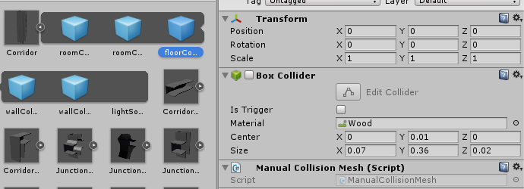

1. Components of a room prefab including the colliders that will be used for player collision.

Having these two approaches to the problem gives users the choice to decide which one they want to utilize, keeping in mind that Mesh Colliders are more resource expensive than basic shape colliders such as the Box Collider. Choosing to use the manual mesh set up for rooms with one exit might be the better option in some cases. For that purpose, the system was designed with multiple approaches for every component where possible.

### Extending the Generator Example – Spawning Dungeon Objects

There are many features that make a game good. From the world, the players find themselves in, to the smallest details. Hence to provide users, who wish to expand the generator into a game, the system is built to integrate easily any additional features.

The system already has an additional feature implemented to serve both as an example of how the system may be extended but also to show users how it could be done. The feature that was implemented was an object spawner. It makes use of the system’s random class to spawn objects at specific locations within the rooms randomly. It uses the ‘DungeonObjectPlacement’ class to determine the location where an object can be spawned. The class also makes use of Gizmos, just like the ‘RoomConnector’ class to help users see where the object will be spawned.

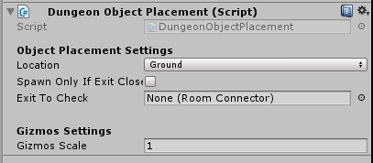

1. Dungeon Object Placement class user interface

As a result, this feature does not only help improve the experience when exploring the level, but it also helps users set a more rewarding experience by exploring it. A room exit object can be specified as the ‘Exit to Check’ value. This option tells the system to spawn an object there only if the exit has been closed – it is a dead end. This contributes to rewarding players for exploring areas not part of the main path.

While only one example of how the system can be further developed has been implemented and discussed, there are many more features that can be implemented. Which features and how they get implemented is entirely up to the users.

### Debugging

Finding out the source of an issue can sometimes be a tedious task. In a larger project, it is quite useful to have appropriate messages displayed while testing the implemented system. For this reason, the system that was created for this project has a debugging feature implemented. There are different options that can be enabled from the ‘Debugging’ section within the ‘Dungeon Generator’ script user interface.

It provides users with information regarding the status of each of the main steps the system takes when generating a level. The information is stored in a text file inside the folder where the project is located. It can then be used to identify which step of the generation processes caused the issue. This feature can further be extended by logging additional information to the file.

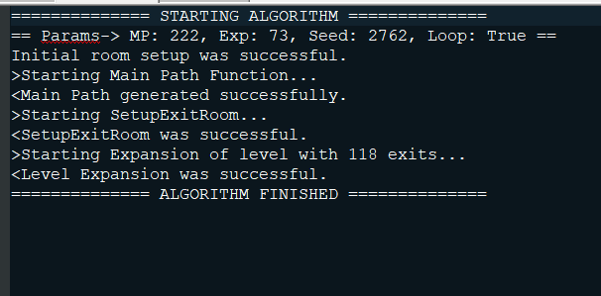

1. Example of debugging log.

Furthermore, it can also give users visual indications such as how the colliders are set up dynamically. And it even provides an indication of the number of rooms and other game objects that have been generated in the Hierarchy.

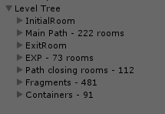

1. An indication of how many game objects have been created during the level generation. This is found in the Hierarchy.

In addition to having a log file for messages, the system provides a second type of log. In the event of a critical error, the system will generate an error message in a separate text file. This error log is created regardless of whether the debug log has been activated. This is due to the fact that errors should clearly stand out when they occur during the level generation. Errors are an indication that there is either an issue with the prefab setup or the way the models were designed – such as number of exits, the location of those exits within the room and number of rooms models the system is working with.

## Testing the Generated Levels

As it was mentioned earlier in the dissertation, one of the main aspects of a good game is that the levels that players are exploring make sense to them. In other words, they have a logical flow from the start of the level to the finish. This is something that the system cannot test for by itself. There are other factors that would affect this aspect such as the design of the room models, monsters and treasures within those rooms. These factors were not implemented, and hence the levels were tested purely on their structure.

In order to test whether the system generates levels that make sense to the players, a survey was conducted. For the purposes of the survey, the system was built and exported using the Unity3D Engine. The system generated levels with between 10-30 rooms for both the main path and the expansion of the level. The executable files along with a link to the survey were given to eight people who showed interest in testing the system. They were instructed to keep in mind this is not a fully implemented game, and their answers on the survey must remain about the room structure and layout within the level rather than the design of the rooms. Players were told to try and find the exit room, coloured red, in each of the levels. After finding the exit in a level, they were to restart the level which would randomly pick a new seed value and two random values between 10 and 30 for the room count.

After exploring several levels, players were asked several questions regarding whether the level made sense to them, whether they got lost for too long while exploring and if the levels seemed unique every time they restarted it.

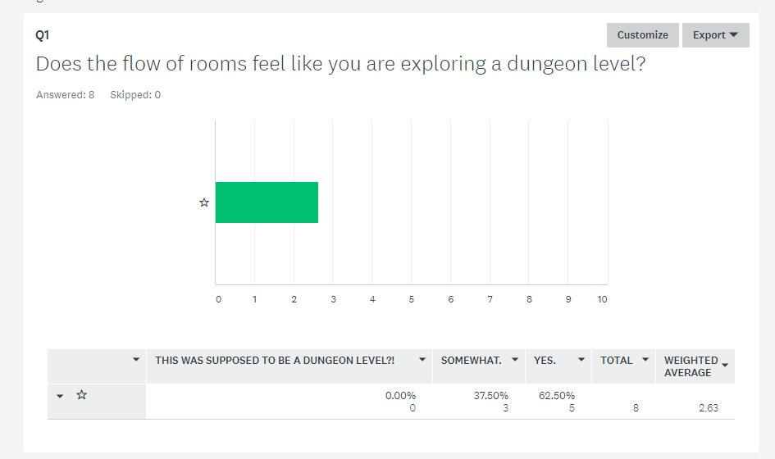

1. Survey results for the first question.

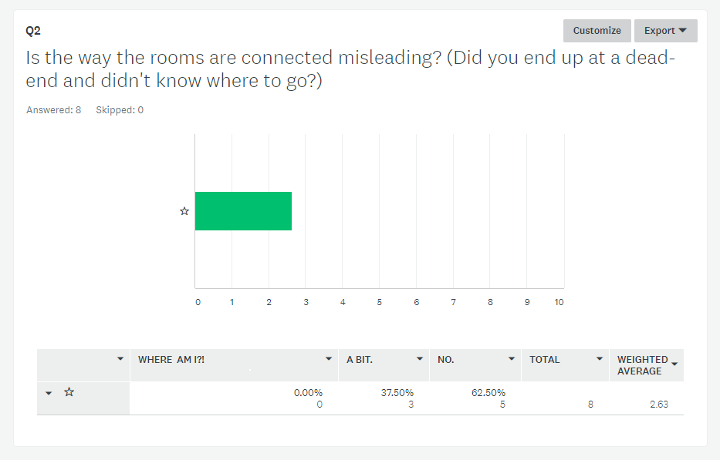

1. Survey results for the second question.

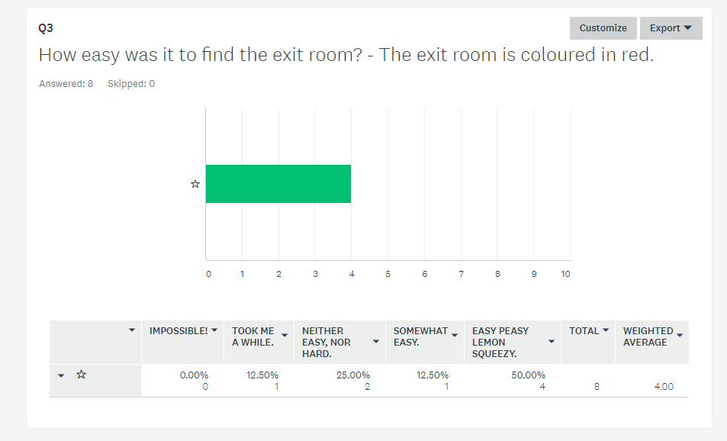

1. Survey results for the third question.

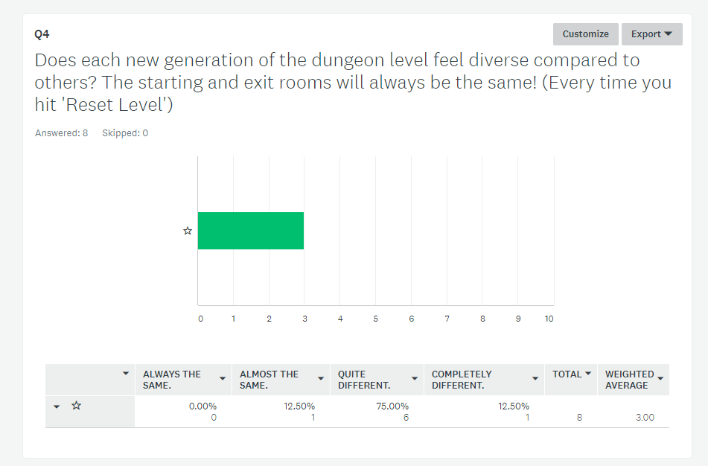

1. Survey results for the fourth question.

The results showed that the players did not have too much trouble finding the end of the level which was the exit room marked in red. It also showed that the flow of rooms appeared to have the desired effect – despite lacking design and gameplay features, the rooms were connected in a sequence that makes sense to players.

More importantly, the results exposed one of the issues with the system. The diversity of the levels it generates depends on the number of room models that it has been supplied with. This issue is discussed further in chapter 4.2. Moreover, a solution to this problem is proposed in chapter 4.3.

# Conclusion

## Summary

The idea for the project was inspired by the room-based generation system in the video game Diablo 3. Thus the focus of this project was to design and implement a system that uses procedural content generation to produce dungeon levels for a game. This was done by using the Unity3D engine and C# as a foundation for the system and using imported room models for the rooms themselves. Moreover, the system that was implemented is designed to be extended into a more advanced dungeon generation system or into a video game. This was accomplished by providing users with a friendly user interface through which they can set up and generate levels. This was aided by writing clean and commented code for those that decide to go into the code and modify/extend any of the current features that are part of the system.

Procedural content generation transforms math equations into incredible creations. It is a field that is still being explored, and various techniques and algorithms are still being designed and implemented by video game developers to create better and improved worlds every time. The video game ‘No Man’s Sky’ is one such example. When the game came out, players were rather disappointed in the generated worlds they were exploring. However, the developers released an update soon after which brought a completely new universe. The procedural generation algorithm, ‘Uber noise’ had been slightly modified. This resulted in not only a brand new world for the players to explore but also brought more diversity to the planets which were a welcomed change to the game. Additionally, ‘Uber noise’ which is the developer's creation not only shows the potential of procedural content generation but also shows there are still a lot of ideas for it that have not been explored yet.

The project pipeline included researching procedural generation and various techniques and ways it can be used to generate content. This, in turn, led to brainstorming ideas regarding how the generation in Diablo 3 and Warframe has been achieved. Hence, a room-based approach was taken. While the initial system that was built worked with only floor models or tiles, the solution has gone through vigorous re-designing throughout the system development. For this reason, the final version of the system is much more user-friendly and accepts raw room models to be used in the generation. Furthermore, it can easily be adapted to suit other purposes.

To sum up, the solution that was implemented has achieved most of the objectives of the project. It successfully generates unique levels using room models provided by the users and comes with comments and tooltips in both the Unity3D Editor and the script code. In addition, it gives users a variety of components that can be used to further develop the solution and thus produce more diverse and creative levels. However, there are areas of the project that the solution has not covered which are discussed in the next sections. A solution for each of those areas/issues is proposed in chapter 4.3. Extending this project could lead to a system that rivals the Warframe generation system. It would require a lot more work, but the base for that has been set in this project.

## Evaluation

The system that was built for the project has much more to be desired. On the one hand, it generates unique levels for every different ‘seed’. On the other, it has some notable drawbacks. Here are the more essential advantages and disadvantages of the system.

***Pros:***

1. The levels that are generated do not have overlapping rooms.
2. The scale of imported room models does not cause an issue as this is taken into consideration when doing collision tests.
3. The level design can easily be extended by adding additional scripts.
4. The system allows for textured rooms to be imported and used in the generation.
5. The system can easily be modified and further functionality can be added.

***Cons:***

1. The diversity of the levels depends on the number of room models that have been provided. Fewer room models would result in less diversity, and the levels would seem somewhat similar.
2. The system does not keep track of the room sequences and their locations in the world – it only tracks a room’s neighbours.
3. The exit room cannot be placed at a specific location in the world.
4. If a corridor cannot be closed due to the ‘close-off’ room colliding, the corridor is sealed and becomes a corridor leading nowhere.
5. The system does not have a custom Inspector but instead uses the default Unity3D Inspector.
6. The system does not provide the option for a collision mesh to be used for room collision detection.

Apart from the cons that have been mentioned, the system design has also overlooked an important feature – the background within the level or background around the rooms themselves. As a result, the room models would have to be created with surrounding textures. Alternatively, additional textures can be created separate from the room models and spawned in the level next to the rooms. With the current implementation, the levels are literally floating in mid-air when viewed from above.

## Future Work

The system would benefit from having all of the issues mentioned in the previous sections addressed. The following steps could be taken to fix the issues:

* 1. To improve the diversity of the generated levels when there are a small number of room models, the system could be extended to use multiple components to construct each room. For example, having more empty spaces within the models and providing several elements that can be placed in those empty spaces. This will modify not only the style of the rooms but also their structure. This is similar to how the ‘Fragment’ class is designed.
  2. The issue of not keeping track of where the rooms are can be addressed by extending the ‘Room’ class and by using a data structure. The game world would become a grid, and a room can be placed in each square. It can even be expanded into multiple dimensions, so there are different height levels within a single square. This would also partially solve the issue of the system not being able to place the exit room at a specific location. Pathfinding algorithms would also have to be used.
  3. While the issue with corridors leading nowhere is partially fixed by having an item that can spawn there if the exit is closed, a better solution might be to replace those corridors with a randomly picked ‘close-off’ room.
  4. Addressing the custom Inspector issue to provide a better user interface would require making use of the ability to override the default Inspector. This is a feature that is provided by the engine itself. However, it is rather time-consuming.

Undoubtedly, there are other features that could be implemented that the system would benefit from. Currently, it does not allow users to use more than one room prefab for the entrance and exit rooms. The diversity of the levels will be improved if the system chooses from a list of room prefabs for each of those two rooms. Moreover, it could be extended to use a certain type of room prefabs – for example, having different sets of room prefabs for different level styles (swamps, forests, castles, etc.).

For the purpose of adding dynamically generated background around the rooms within the level, the various procedural content generation techniques and algorithms, mentioned in the State-of-the-Art section, can be used. This will allow users to specify a texture they would like to use. This, however, leads to other problems such as avoiding generation inside the rooms themselves. As well as issues such as generating organic and sensible terrain related to the art style of the room models.

Alternatively, another solution to the problem discussed in the previous paragraph could be to use room prefabs that are solely created for the purpose of being a background to the levels. The system would then spawn them within the level based on the properties of each of the room prefabs. With this in mind, the system and room scripts would have to be extended to provide the functionality for setting up which background room prefabs can be spawned on which sides of the rooms that are part of the level. However, a simpler and perhaps more effective way of achieving the desired effect is to use background images which can be added around the room prefabs as they will not interfere with the collision detection algorithms.

Overall, the system that was implemented for this project is quite flexible. This is not only due to the fact that users are presented with multiple ways of using the essential components of the system, but it also does not limit users to a certain type of models that they can use. While the system is focused on the idea of room structured levels, it can also work with models that are not room shaped. For example, the models that are used can be tiles with a path in them.

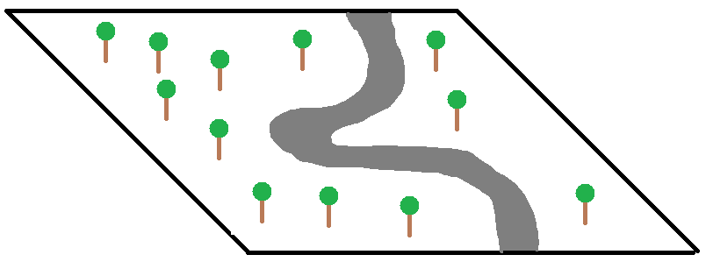

1. A basic design of a model that can be used with the system – showing a path between two sides of the tile and trees around that path.

Models such as the one in the figure above can be imported into the Unity Engine and used for level generation. While the model in the figure was the designed to get the idea across, these models can be quite more complex – comprising of missing chunks to be added dynamically is one example. With this in mind, the system can be used to generate levels that are not dungeons. In other words, it can be used to generate outdoor levels with rivers and mountains simply by supplying a different style of models. Thus leading to more variety in the levels which are generated.

References

[1] Outerra.com. (2018). Outerra. [online] Available at: <http://www.outerra.com/> [Accessed: 04 March 2018].

[2] Pcg.wikidot.com. (2018). Whittaker Diagram - Procedural Content Generation Wiki. [online] Available at: <http://pcg.wikidot.com/pcg-algorithm:whittaker-diagram> [Accessed: 04 March 2018].

[3] Pcg.wikidot.com. (2018). Minecraft - Procedural Content Generation Wiki. [online] Available at: <http://pcg.wikidot.com/pcg-games:minecraft> [Accessed: 04 March 2018].

[4]  Paul Hellquist, (2018). [online] Available at: <http://www.gearboxsoftware.com/2013/09/inside-the-box-the-borderlands-2-loot-system/> [Accessed: 04 March 2018].

[5] Reddit. (2018). “Anyone have details on how Diablo 3's rifts are generated?” [online] Available at: <https://www.reddit.com/r/proceduralgeneration/comments/6lu265/anyone_have_details_on_how_diablo_3s_rifts_are/> [Accessed: 04 March 2018].

[6] Pcg.wikidot.com. (2018). *Fractal - Procedural Content Generation Wiki*. [online] Available at: <http://pcg.wikidot.com/pcg-algorithm:fractal> [Accessed: 04 March 2018].

[7] M. Seredynski, "Bake Your Own 3D Dungeons With Procedural Recipes", *Game Development Envato Tuts+*, 2018. [Online]. Available: <https://gamedevelopment.tutsplus.com/tutorials/bake-your-own-3d-dungeons-with-procedural-recipes--gamedev-14360> [Accessed: 05 March 2018].

[8] C. LLC, "AWESOME SNOW BIOME SEED Minecraft Project", *Planetminecraft.com*, 2018. [Online]. Available: <https://www.planetminecraft.com/project/awesome-snow-biome-seed/> [Accessed: 05 March 2018].

[9] "Minecraft : Biome Jungle", *Fr-minecraft.net*, 2018. [Online]. Available: <http://fr-minecraft.net/biome-21-jungle.html> [Accessed: 05 March 2018].

[10] "Minecraft : Biome Plaine de Tournesols", *Fr-minecraft.net*, 2018. [Online]. Available: <http://fr-minecraft.net/popup_biome.php?biome=129> [Accessed: 05 March 2018].

[11] "Minecraft : Liste des biomes Minecraft", *Fr-minecraft.net*, 2018. [Online]. Available: <http://fr-minecraft.net/52-biomes-minecraft.php> [Accessed: 05 March 2018].

[12] "Outerra", *Outerra.com*, 2018. [Online]. Available: <http://www.outerra.com/> [Accessed: 05 March 2018].

[13] "Atlas Home", *No Man's Sky*, 2018. [Online]. Available: <https://www.nomanssky.com/> [Accessed: 05 March 2018].

[14] "If I May Speak Procedurally, Sir: Building The British Countryside Generator | BIG ROBOT", *Big-robot.com*, 2018. [Online]. Available: <http://www.big-robot.com/2012/07/02/procedural-british-countryside-generation/> [Accessed: 05- Mar- 2018].

[15] "Behold, Countryside Generator Screenshots! | BIG ROBOT", *Big-robot.com*, 2018. [Online]. Available: <http://www.big-robot.com/2012/06/11/behold-countryside-generator-screenshots/> [Accessed: 06 March 2018].

[16]"Unity - Using the Inspector", Docs.unity3d.com, 2018. [Online]. Available: <https://docs.unity3d.com/352/Documentation/Manual/UsingTheInspector.html> [Accessed: 11 March 2018].

[17] U. Technologies, "Unity - Scripting API: SerializeField", *Docs.unity3d.com*, 2018. [Online]. Available: <https://docs.unity3d.com/ScriptReference/SerializeField.html> [Accessed: 10 March 2018]

[18] Technologies, U. (2018). Unity - Scripting API: Collider. [online] Docs.unity3d.com. Available at: <https://docs.unity3d.com/ScriptReference/Collider.html> [Accessed: 10 March 2018].

[19] U. Technologies, "Unity - Scripting API: Gizmos", *Docs.unity3d.com*, 2018. [Online]. Available: <https://docs.unity3d.com/ScriptReference/Gizmos.html> [Accessed: 11 March 2018].

[20] "Unity - Enumerations", *Unity*, 2018. [Online]. Available: <https://unity3d.com/learn/tutorials/topics/scripting/enumerations> [Accessed: 11 March 2018].

[21] "Unity - Prefabs", *Docs.unity3d.com*, 2018. [Online]. Available: <https://docs.unity3d.com/352/Documentation/Manual/Prefabs.html> [Accessed: 11 March 2018].

[22] U. Technologies, "Unity - Manual: Tags and Layers", *Docs.unity3d.com*, 2018. [Online]. Available: <https://docs.unity3d.com/Manual/class-TagManager.html> [Accessed: 12 March 2018].

[23] U. Technologies, "Unity - Scripting API: Mathf.PerlinNoise", *Docs.unity3d.com*, 2018. [Online]. Available: <https://docs.unity3d.com/ScriptReference/Mathf.PerlinNoise.html> [Accessed: 15 March 2018].

[24] “Simplex Noise, a Unity C# Tutorial", *Catlikecoding.com*, 2018. [Online]. Available: <http://catlikecoding.com/unity/tutorials/simplex-noise/> [Accessed: 15 March 2018].

[25] "Perlin noise", *En.wikipedia.org*, 2018. [Online]. Available: <https://en.wikipedia.org/wiki/Perlin_noise> [Accessed: 15 March 2018].

[26] "Simplex noise", *En.wikipedia.org*, 2018. [Online]. Available: <https://en.wikipedia.org/wiki/Simplex_noise> [Accessed: 15 March 2018].

[27] "Understanding Perlin Noise", *Flafla2.github.io*, 2018. [Online]. Available: <https://flafla2.github.io/2014/08/09/perlinnoise.html> [Accessed: 15 March 2018].

[28] "Random Noise", *Fxfactory.com*, 2018. [Online]. Available: <https://fxfactory.com/downloads/docs/noiseindustries/fxfactorypro/Documentation/generators/randomnoise.html> [Accessed: 15 March 2018].

[29] "Heightmap", En.wikipedia.org, 2018. [Online]. Available: <https://en.wikipedia.org/wiki/Heightmap> [Accessed: 15 March 2018].

[30] "the definition of simplex", *Dictionary.com*, 2018. [Online]. Available: <http://www.dictionary.com/browse/simplex> [Accessed: 15 March 2018].

[31] "Google Code Archive - Long-term storage for Google Code Project Hosting.", Code.google.com, 2018. [Online]. Available: <https://code.google.com/archive/p/fractalterraingeneration/wikis/Simplex_Noise.wiki> [Accessed: 18 March 2018].

[32] *Code.google.com*, 2018. [Online]. Available: <https://code.google.com/archive/p/fractalterraingeneration/wikis/Midpoint_Displacement.wiki> [Accessed: 18 March 2018].

[33] *Code.google.com*, 2018. [Online]. Available: <https://code.google.com/archive/p/fractalterraingeneration/wikis/Diamond_Square.wiki> [Accessed: 18 March 2018].

[34] “Path of Exile - Random Level Generation Presentation”, YouTube: Grinding Gear Games, 2011  
Available: <https://www.youtube.com/watch?v=GcM9Ynfzll0> [Accessed: 18 March 2018]

[35] MarkCC, “Fractal Curves and Coastlines”, 17 July 2007 [Online]   
Available: <http://goodmath.scientopia.org/2007/07/17/fractal-curves-and-coastlines/>  
[Accessed: 18 March 2018]

[36] "Tile Sets", *WARFRAME Wiki*, 2018. [Online]. Available: <http://warframe.wikia.com/wiki/Tile_Sets> . [Accessed: 29 March 2018].

[37] "2013-05-24 00012.jpg", *WARFRAME Wiki*, 2018. [Online]. Available: http://warframe.wikia.com/wiki/File:2013-05-24_00012.jpg. [Accessed: 29 March 2018].

Appendix 1 – User Guide

**Creating a Unity3D Project**

Create a new 3D project using the Unity3D interface and copy the source files over to the Assets folder within the project folder.

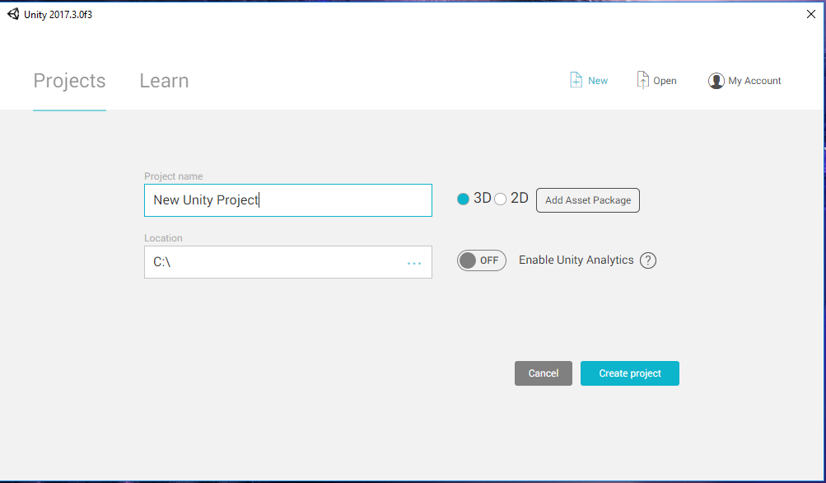

**Setting up a Room Prefab**

1. Import a room model.
2. Drag and drop it into the scene. This will turn the model into a game object and you will see it in the Hierarchy.
3. Create a new folder within the project folder and call it ‘Prefabs’.
4. You should see the new folder in the Unity Project View.

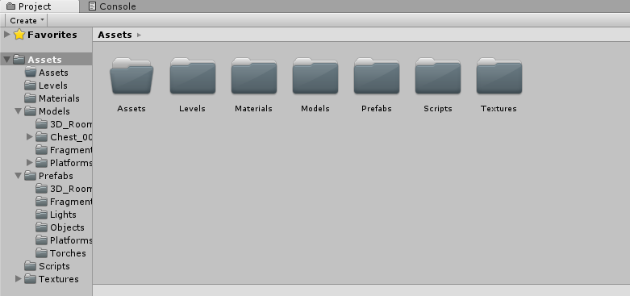

1. Drag and drop the room game object from the Hierarchy into the folder. This will create a prefab for that object.
2. Add a ‘Room’ script to the room game object or prefab.
3. Set the objects tag to ‘Room’.
4. Add a collider of a type you think will best cover the room. If the collider fits the room perfectly, delete the collider and move on to the next step. Otherwise, change the position and size of the collider, so it fits the room as best as possible. Now copy those new values into the ‘Algorithm Collision Settings’ section. Delete the collider component.
5. If you will be using a collision mesh reference it in the ‘Player Collision Settings’ and leave ‘Custom Collision’ unchecked and proceed to the next step. Otherwise, tick the ‘Custom Collision’. Now add a new object as a child to the room game object. Add a ‘Manual Collision Script’. Add a collider and position it to where you would like the player not to be able to go through. Do this as many times as necessary. You can use two colliders in the same object when they are the same size. For example, in the image below, there are 4 objects that have been used to set up the player collision – wall with two colliders (1), floor with one collider (2), wall with two colliders (3) and a wall with one collider (4).

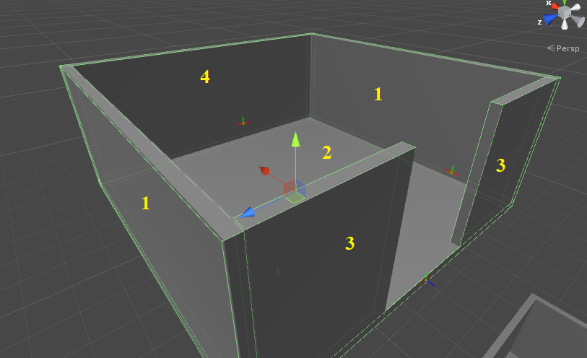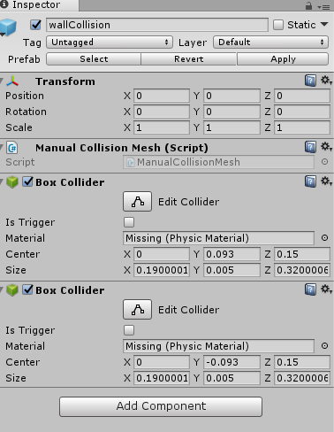

1. Add a new empty game object as a child of the room game object for every exit the room will have. Add the ‘Room Connector’ script to each one. Now position the object where the room should connect to other rooms. The object might have to be rotated to face the correct direction.

To figure out whether it needs to be rotated, press 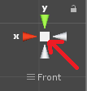. This will change the scene view. The ‘X’ axis needs to point left.

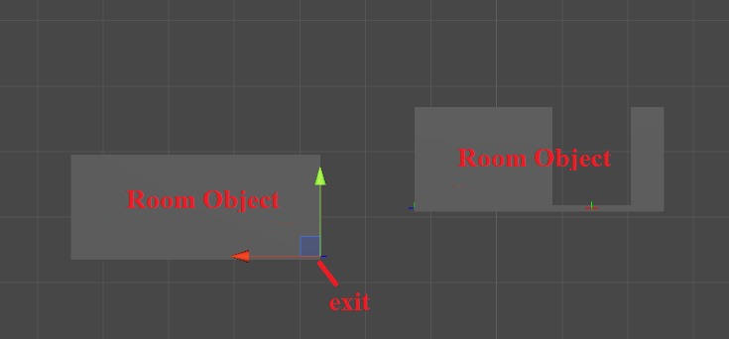

If you are working on the game object and not the prefab, save it by clicking the ‘Apply’ button at the top in the Inspector. 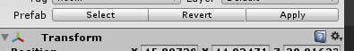

1. Delete the room object from the Hierarchy.

**Setting up a Fragment**

1. Import the fragment model.
2. Drag and drop it into the scene. You should see it in the Hierarchy as well.
3. Drag and drop the object from the Hierarchy to the Prefabs folder to make it into a prefab.
4. Add the ‘Fragment’ script to it.
5. Change its tag to ‘Fragment’.
6. Configure the player collision the same way as setting up the player collision for a room prefab.
7. If needed, adjust the rest of the settings. Running the system shows whether a those settings need adjusting. This depends on the rotation of the fragment model on import.

**Setting up the Level Generator**

1. Once in the Unity Editor, create a new empty game object.

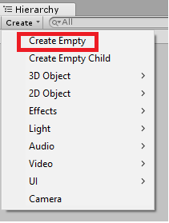

1. Select the newly created game object and name it something appropriate such as ‘Dungeon Generator’. Select it and then in the Inspector add the ‘Generator Script’ which can be found under ‘Room-Based Generator Scripts’.

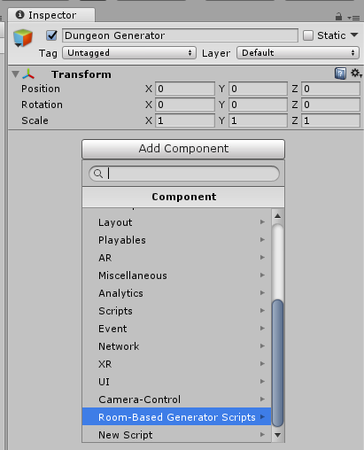

This will add two scripts – ‘Connection Rules’ and ‘Room Based Generator’. Both of these will need to be configured for the system to work. If ‘Connection Rules’ is not configured, the system will use default connections.

Drag and drop the already created prefabs into the appropriate slots. For example, you can drag and drop multiple room prefabs into the ‘Rooms’ slot which will also automatically adjust the size.

Finally, set the objects tag to ‘DungeonGenerator’.